### DCPS

May 18th- 22nd

Last Newsletter

**Remember me**

**Summer Checklist:**

1. Don’t forget to Read: Here are some great chapter book suggestions.

Magic Tree House

Ivy and Bean

The Last Kids on Earth

The Box Car Children

I Survived

The Hardy Boys

Who Was Series

Junie B Jones

Geronimo Stilton

Judy Moody

Ask Me Why?

A to Z Mysteries

My Weird School

Goosebumps

Cam Jansen

2. Reflex: Your child will have the rest of the summer to work on multiplication and division. This is a great resource to use to be prepared for 3rd grade!

3. Please remember that all of our computer programs will be available this summer. You can access these accounts on your teacher’s website through lab links.

We hope you have a Great Summer!!

**3 R’s: Read/Reflex/ReadingEggspress**

Fiction Book: The Secret Egg

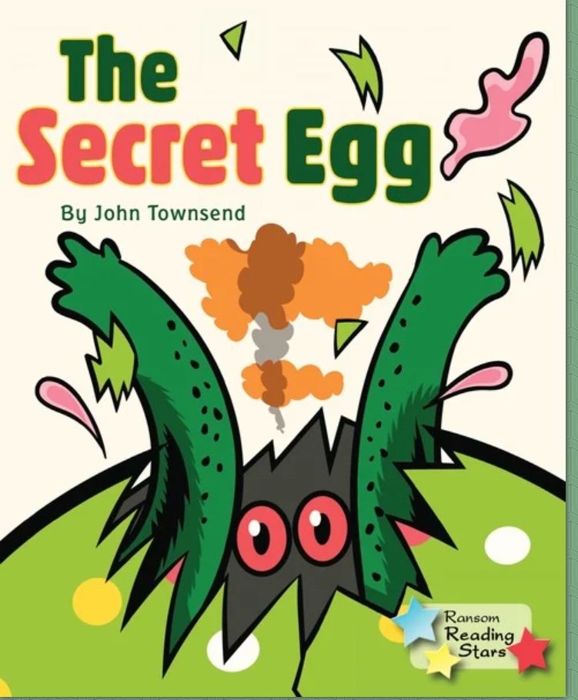

Non-Fiction Book: Magical Creatures

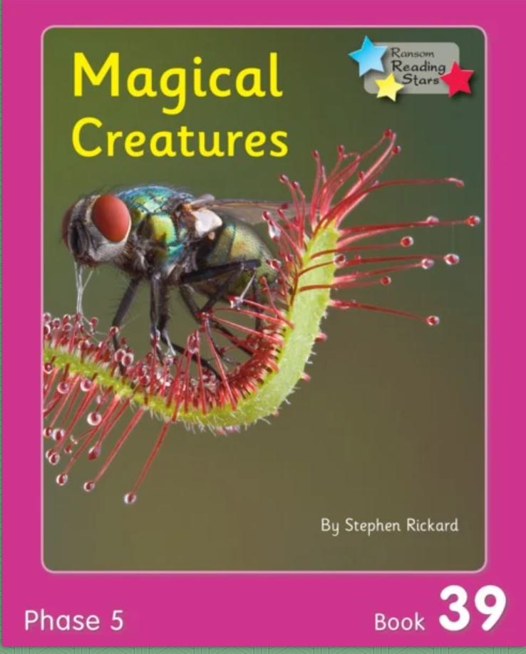

2nd Grade News

**Comprehension Questions Parents Can Ask:**

1. Why is this The Secret Egg title of the story? Can you think of another title that could replace it?

2. There are a lot of adjectives in this story. Remember an adjective describes a noun. What are three adjectives you could use to describe yourself?

3. Make a story web. Include characters, setting, problem, and solution.

**Math Skills**

😊Did you get a green light on Reflex today?

This week your teacher will post on their website:

* Word Problem of the Day
* 9 Box Review

Remember you can do this on notebook paper too.

Videos for kids:

<https://youtu.be/6LiBqvzMh-E>: Mythical Creatures

<https://youtu.be/Nbuu1Fa-c1k>: Stingray Mythical Creatures

<https://youtu.be/uhfXbSSrabw>: Gecko Feet: How do they stick to walls?

Writing Prompt

The last sentence in The Secret Egg was: Their story’s only just begun… who knows where it will all end? Write a paragraph about the dragon and the cat’s friendship. Don’t forget to include an opening and a closing.

**Comprehension Questions Parents Can Ask:**

1. What are two text features you found in the text? Why are they important?

2. List 3 facts you learned from the text.

3. Which magical creature would you like to learn more about and why?

## Phonics