Welcome to 10th Grade Literature
Teacher: Ginger Smith
__________________________

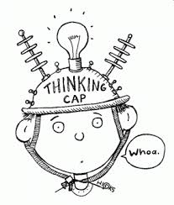
Goals: The goal of this class is to get you ready for the EOC and eventually college, tech school or the working world. Being literate is one of the major skills that the work world requires and it’s one of the skills that will make you an attractive job candidate.
- To write essays on any topic using an organized method.
- To write excellent narratives anytime and anyplace.
- To know the kinds of research/writing that will help you succeed in college.
- To make you more excellent readers.
- My personal goal is to see everyone in this class show growth and do their best!
___________________________________
Teacher Expectations:
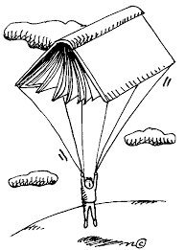
- That you will focus on class. This is not the time for off task talking or playing—save that for later.
- You will not disrupt class learning. We have a new curriculum and format for class that takes a lot of concentration. Repeatedly interrupting the learning process will result in a write up as well as a decline in your average because you are not paying attention.
- We are all here to help each other. Making fun of people/bullying is not allowed in any fashion.
- I expect you to have a good attitude about 90% of the time. You’d be surprised what you can do just by TRYING. Those successful people you want to be like…they are not successful because they are lucky, they are successful because they TRY and WORK HARD.
- We won’t do everything right the first time, but we will have a fun time learning from our mistakes and getting better and better.
NEW CELL PHONE POLICY
- Cell phones must be put away in your locker or in the designated cell phone area when you are in class. I should not see your phone on your desk or in your hand. Cell phones are being used to cheat in class, so they can no longer be allowed. This serves as your warning, so if I see your phone in your hand or on your desk, I’m taking it the VERY first time.
  - Warning: You’ve already had it. This notice is your warning.
  - First offense: I take your phone and keep it until the end of the day. I may decide to call home on this offense.
  - Second offense: write up, parental call home and the office will get your phone.
  - Third or more—Office Referral/discipline policy.

Behavior Policy:
- No talking when the teachers are talking.
- Treat others with respect and courtesy. Be polite. Help others in our room when you are able.
- Use time wisely. No playing. There is no time for off task behavior. If you have extra time, you should read a book!
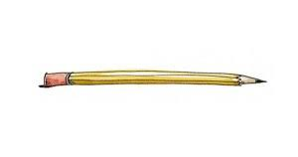
___________________________________

Supplies:
- Pens (blue or black ink)
- Pencils
- Paper and Notebook (preferably one with a few sections.)
- Highlighters
- Post It Notes or Flags
________________
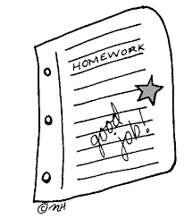
Grading:
40% Writing projects and tests (Writescore benchmark or teacher made.)
25% homework and classwork
15% quizzes and participation

_________________
Topics: We have a totally new curriculum this year so it will be a learning experience for all of us. We will be reading Homer’s The Odyssey.
- We will still be doing Writescore/Readscore to help us get ready for the EOC. It worked very well last year!!
- We will study speeches, stories, poems and other nonfiction pieces. We will practice some new reading strategies to give us tools for our toolbox.
- Instead of covering LOTS of material, we will be covering a smaller amount, but in ways that take you more deeply into things like author’s purpose, tone, diction, etc…all those nifty little things that you see on the EOC!
- One of the topics we will be looking at is the hero’s journey.

Extra Help Policy:
I am always here to help you before or after school and at lunch if you need extra help. I consider that a teacher’s job.
BUT if you goof off all year then want me to give you extra credit at the end, you may end up disappointed. Don’t wait too late.

