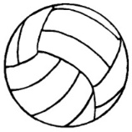
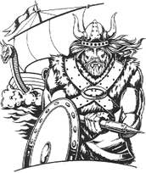
Banner Order Form
The MGM Lady Vikings appreciate your support for the volleyball team. A banner is an excellent opportunity for recognition of your business. Banners will be 3’x5’. Thank you for your support of our athletic program.
Renewal $100 New Banner $175

Amount ____________________ received by____________________
Please keep this top portion for your records and send a business car or write what you would like on the banner below and send it back with the player.
Thank you,
MGM Volleyball

Player___________________________________________
Business_________________________________________
Amount (Circle One): New = $175 Renewal: $100

What I want on the banner.

