In collaboration with ALSDE, Baldwin County Public Schools, and PowerSchool
SIS Enrollment
PrACTICAL POWERSCHOOL

Security Settings
Page Permissions – there are no security group controls
Roles Administration – Enable Provisional Enrollment Notifications
There is not a prompt, however you will see a number show on this icon at the very top

Transferring Students Out (aka Withdrawing Students) – Within District and Within State
- Search for the student
- Click Functions (under Enrollment menu on the left)
- Click ‘Transfer Out of School’
- Enter any transfer notes under Transfer Comment
- Enter the date of withdrawal
- Enter the Exit code
- Enter the destination District and School
One extra step for Within District only:
- Click Functions and select Transfer to Another School

Enrolling New Students from Another School – Within District
NOTE: There are two functions that must be completed by the losing school BEFORE you can enroll a student within the same district: (1) The student must be transferred out and (2) The student must be transferred to your school. Instructions are listed above.
- Search for the student using the forward slash (/) and student name (this searches for inactive status)
- Click Functions (under Enrollment menu on the left)
- Click ‘Re-Enroll in School’
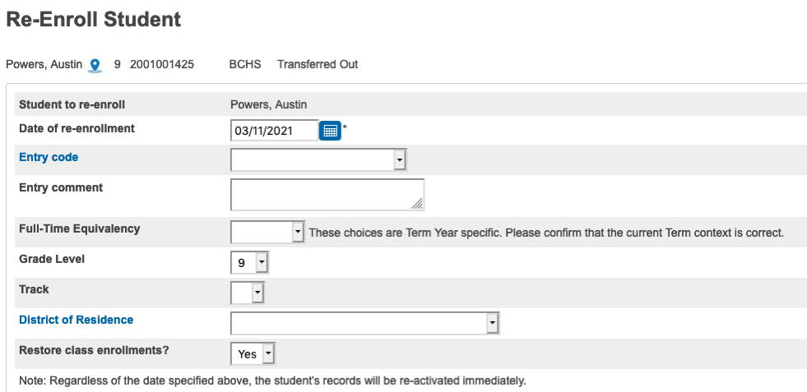

Enrolling New Students from another LEA/School – Within State
- Click Enroll Student (under People menu)
- Enter the required data fields for searching State Locator
- The matchback screen will display the student names in % match order. More than likely the student you are looking for will be listed first with the highest % match.
  - If you find the correct match, click the bullet next to the student’s name and scroll to bottom and click Next
  - If you do not find the correct match, scroll to the bottom and select ‘No Match, New Enrollment’ and click Next
- The next screen will prompt you to match any Family members and allows you to copy some information from one student to another. (Note: You have to set at the district level which field(s) to copy and share. District Setup | Family Management)
- (Note: This last step is only necessary if the student was previously enrolled in your district.) To complete the enrollment, proceed to Functions (under Enrollment menu on the left) and click ‘Re-Enroll in School’

Enrolling New Students from PowerSchool Enrollment (formerly InfoSnap) – Within State
- Within PS Enrollment, approve the submission record as normal
- When delivering the record, it will find student matches within the district
  - If there is no match (i.e. brand new student to the district), select No Match
  - If there is a match, you must contact the last BCBE school and use the function ‘Transfer to Another School’ to set to your school. Do not attempt to deliver until the transfer is complete., the delivery will fail.
- Upon successful delivery, the student will have an E90 provisional enrollment code
- Within PS SIS, click the Provisional Enrollment menu on the left
- Under the area of E90, you should see the newly enrolled student
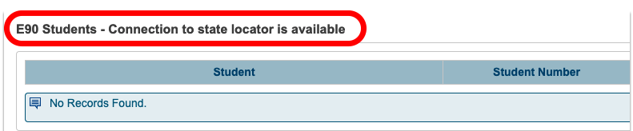

Provisional Enrollment Definitions
(Note: This is only for within state transfers and enrollments)

Resolving E99’s (Within State ONLY)
- Click the Provisional Enrollment menu on the left
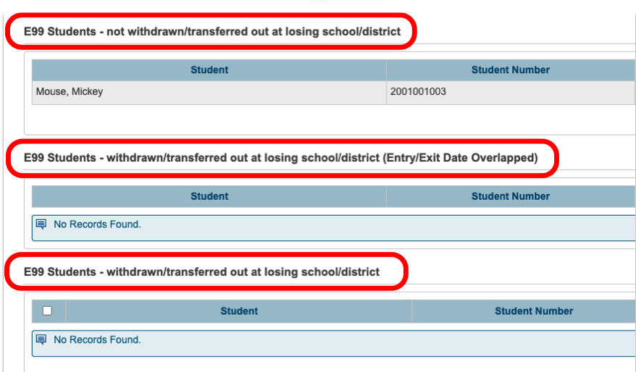
E99 Students – not withdrawn/transferred out at losing school/district
This list will display the students that you caused the E99’s on, meaning you enrolled the student before he/she was transferred out/withdrawn from their previous school/district.

E99 Students - withdrawn/transferred out at losing school/district (Entry/Exit Date Overlapped)
This list will display the students that have been processed (transferred out/withdrawn) however there is an overlap with entry dates and/or the withdrawal dates.

E99 Students - withdrawn/transferred out at losing school/district
This list will display the students that have been processed (transferred out/withdrawn) and are ready for you to resolve the E99.
Resolving E98’s (Within State ONLY)
- Click the Provisional Enrollment menu on the left
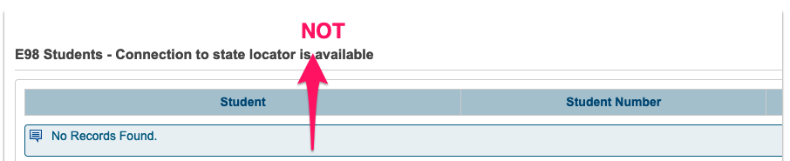
- This list will display the students that were enrolled at the time state enrollment was down. Once state enrollment connection is restored, you can resolve the E98’s.

Students provisionally enrolled at other schools/districts (Within State ONLY)
- Click the Provisional Enrollment menu on the left
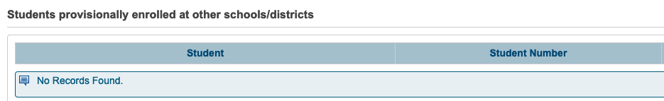
This list will display the students that were enrolled in another school/district and were not withdrawn from you (formerly also called E99). You can process the transfer out/withdrawal for these students on this screen.

