Red Ribbon Week Activities
Autaugaville School
October 26- October 30, 2002

Monday  October 26th | Tuesday  October 27th | Wednesday  October 28th | Thursday  October 29th | Friday  October 30th
Sock it to drugs!  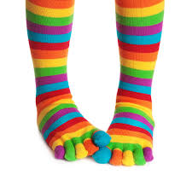  Wear your favorite pair of Crazy socks | Put a cap on drugs!  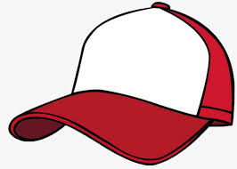  Wear your favorite cap | War on drugs!  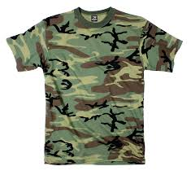  Camo day. Wear camo shirt and or pants | Your future is bright without drugs!  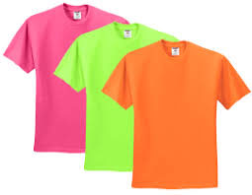  Wear neon or bright colors | Tackle drugs!  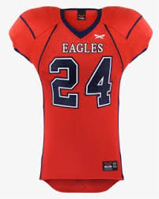  Wear your favorite football jersey

