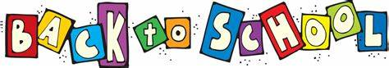

Hickory Flat 3rd Grade Supply List
2020-2021

2-inch binder
Page dividers for binder (5 pack)
4 packs- Loose leaf paper- wide ruled
2- Composition notebooks
3 Packs- index cards
3- 2 Pocket folders
24- Wooden pencils
1 pack Color pencils
1 box of Crayons
1-Yellow highlighter
1 pair Children’s scissors
1 pack- Expo markers
3 Boxes of Kleenex
1 Bottle of Germ-X
1 Can of Lysol Spray
1 Pair of earbuds
3 rolls of paper towels

