Directions for Accessing Google Classroom
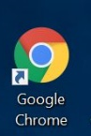
- Open the Google Chrome Browser
- Go to google.com
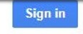
- Click
- Enter your school system email address (username@stu.mcpss.com) in the box and click “Next”. Then you will need to enter the password for your school system account.
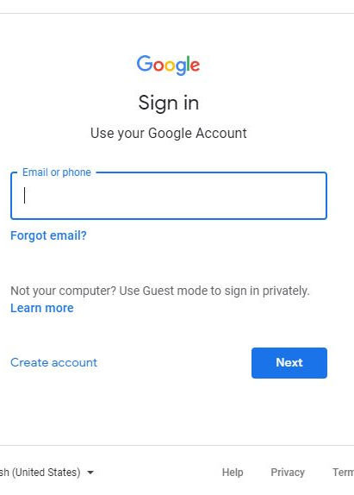

- Enter your school system email address (username@stu.mcpss.com) again to log into the Microsoft account. Click “Next”.
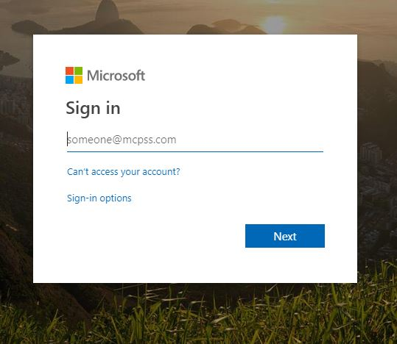
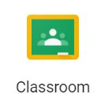
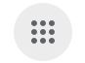
- Click on to launch Google Apps and select the Classroom icon from the menu.

