j0251265[1]

Grades & Grading

**Report Cards**

Students will receive letter grades on their report cards in first grade as well as numerical. The following grading scale will be used:

A = 90 - 100

B = 80 - 89

C = 70 - 79

D = 60 - 69

F = below 60

Report cards are sent home four times per year. Please remember to sign and return the report card and send it back after going over your child’s report card with him or her. Please do the same with Progress Reports.

Please do not hesitate to contact me if you ever have a question about a grade on any assignment. I am happy to help out in whatever way I can.

**Language Arts and Reading Test/Math Test/Grades**

Reading Test/s will be administered on Friday/s with some exceptions (These exceptions will be noted on the weekly newsletter.). The Reading Test is composed of the High Frequency Words (usage in sentences), Phonics-based on the weekly skills, Comprehension-answering questions about the story that’s on the test, and a written answer.

Spelling Tests as well as Language Tests are on Thursdays.

Math Topic Tests will be given when skills have been taught. Topic tests can fall on any day of the week. Some Math Topics are shorter than others with the amount of lessons. These will be sent home immediately after being graded for you to review. If you should need to ask questions, please contact me using the contact information on the cover.

**Science/Social Studies**

Grades are composed of verbal assignments, discussion, participation, written assignments, in and out of class projects.

*Academic Lessons are structured similar with each one beginning with whole group instruction with introducing learning targets/modeling/practice, and then small group with learning stations and/or hands on activities. Technology is incorporated as much as possible. Intervention groups aid students who need extra help. Also, within the class we incorporate cooperative learning as well as some one on one practice to help everyone achieve “Their” academic potential.

**Additional Information**

**Weekly Papers/Binders**

Weekly Papers are sent home inside of binders. Please keep the papers on the side of the binder labeled “Keep at Home” and return papers on the side labeled “Bring Right Back”. There isn’t a particular day that I send graded papers home. Please look for them either the same day as a test or graded assignment or the day after. I try not to hold papers for extended lengths of time. Please check for papers “Daily”. **Please do not throw away papers that should be returned to school**. **Also, everyday students should have their binders at school due to various word lists that we go through and check them off as they are learned.**

**Newsletters**

These will be sent home usually on Friday/s with the weekly homework attached. (If the newsletter doesn’t come home on Friday, it will be sent on Monday due to days out of school, etc.)

**Birthdays**

You are welcome to send in mini cupcakes or cookies for the class to enjoy your child’s birthday. We will have to eat it during our classroom’s scheduled snack time. Birthday invitations will only be passed out if there is an invitation for everyone in the classroom.

**Field Trips**

Field trips enable your child to experience first-hand the concepts that they have been exposed to in the classroom. Your help is needed and appreciated on field trips. However, due to the fact that field trips are an enrichment activity held during school hours, a child who is not enrolled in first grade (including siblings) are not allowed to attend. I do ask that permission slips and money be turned in by the date requested. Money will only be taken up between 7:45 and 8:00. The front office will not accept any money. It is very difficult to organize field trips with several classes if a student’s money and permission slip is not turned in on time. Send it by your child in a sealed envelope. Thank you in advance for your timely cooperation.

**Box Tops**

Please save your Box Tops and send them to school with your child. Box Tops really add up when all of the students bring them to school. The money from the Box Tops can be used to purchase classroom supplies.

**Money**

Please send all money in an envelope labeled with your child’s name, homeroom teacher’s name, and the purpose for the money. Students lose money envelopes regularly and this will help it get to the right place.

**Lunch**

Please feel free to join your child for lunch, a schedule will be provided! **Please wait until after the first 2 weeks of school, so that your child can become adjusted to the routine.** When you arrive, please check in with the office and then wait outside the lunchroom for our class to arrive.

**Transportation**

If your child’s mode of transportation needs to be changed on any given day, such as a child who usually rides the bus will be a car rider, please send a note to school letting me know this. We cannot deviate from the designated method of transportation unless we have it from you in writing. As I receive these, I send them to the office for approval. School dismissal is as follows:

* 1st Load Bus Riders: 3:05
* Car riders: 2:50
* YMCA 2:55/Daycare: 3:05
* 2nd Load Bus Riders: 3:10 (dismissed to wait in lunchroom)
* Walkers: 3:00 *Dismissal times are tentative! At the beginning of school, it takes longer to dismiss.

**Organization**

First grade is a very important year as new skills are covered. Keeping up with class work and homework is extremely necessary. In order to help your child stay organized, he/she will need a three-ring binder as listed in the supply list. All subjects will be kept in the binder so your child has fewer items to keep up with. Students will be asked to take out this binder frequently to place papers in a designated area inside of it. Please reinforce the importance of this at home.

**Homework**

Homework is important because it teaches responsibility and helps the student develop good study habits. Homework is not “busy work”. It is given to reinforce skills and concepts taught that week. Homework helps the students prepare for upcoming lessons and tests**.** It should take approximately 20 minutes, give or take, depending on each individual student. Homework should be a time to reinforce skills learned during the school day. Students will receive Reading homework once a week. The homework can be completed in one night or spread throughout the week. However, Spelling words and High Frequency words should be practiced nightly. Students returning their homework by Friday will receive a sticker or an opportunity to move up on the clothespin chart. Completing homework helps to prepare students to become more responsible and independent workers in the future. Math homework will be given as needed on an individual basis and before a test as a class. Science and Social Studies projects will be given occasionally.

**Attendance Policy**

Students who are absent should bring in an excuse the next day. However, three days are given to submit an excuse. For students not bringing excuses, “Zeros” for assignments will be received due to the unexcused absence.

Five (5) unexcused absences within a school year constitute a student being truant and on the seventh (7) unexcused absences a complaint/petition may be filed against the child and/or parent. • Any time that a student is absent, the parent or guardian must send a written note to school satisfactorily explaining the absence.

**A satisfactory note from parent or guardian meets the following State guidelines:**

1. Illness; 2. Death in the immediate family; 3. Inclement weather (as determined by the principal) which would be dangerous to the life and health of the child; 4. Legal quarantine; 5. Emergency conditions as determined by the principal; and 6. Prior permission of the principal and written consent by the parent or guardian. • The note or doctor’s excuse must be sent to school within three (3) days of the student’s return to school to be counted as an excused absence. Excuses will not be accepted after three (3) days. Please note that teachers are not obligated to provide make-up work for unexcused absences. • A written note from parents or guardians, as described above, will excuse absences for up to but not exceeding ten (10) absences during the school year. Further absences will require a written excuse from a medical doctor or court official. All excuses must be presented within three (3) days of the return to school.

**Award’s Day**

At the end of the school year, we will celebrate school successes with A, AB, and Perfect Attendance. Students receiving these awards must earn honor roll on every report card for all 4 nine weeks. Perfect Attendance award recipients are the students whom attend school every day without checking in and/or checking out.

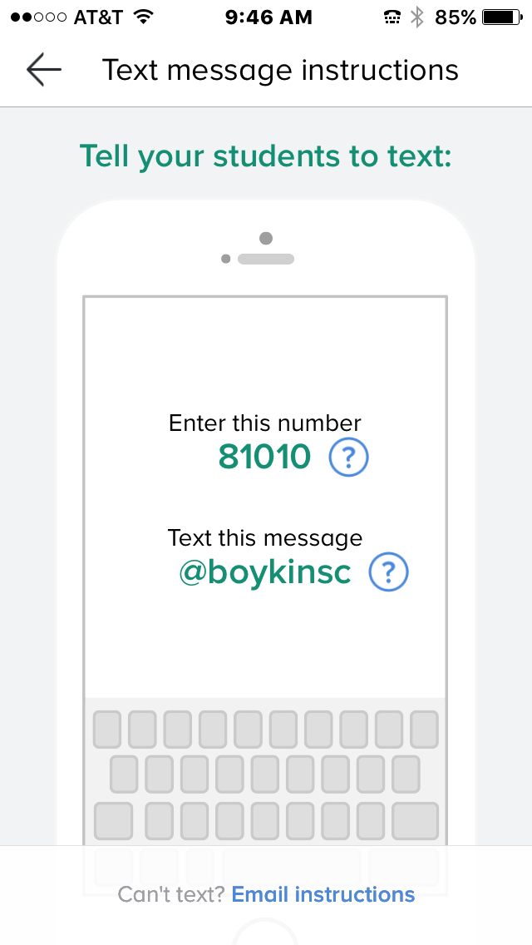

**Student Insight**

STUDENT’S NAME: _______________________

List 3 words that best describe your child:

_______________ _______________ __________________________

Goals you, as the parent, have for your child this year:

________________________________________________________________________________________________________________________________________________________________________

How does your child learn best?

____________________________________________________________________________________

____________________________________________________________________________________

Other helpful information:

___________________________________________________________________________________

___________________________________________________________________________________