
KA Newsletter


Mrs. Blatch
Email: kimberly.blatch@southern.k12.oh.us

2/10/20-2/14/20
1

Words to Practice
yellow
blue
green
red
purple
pink
orange
black
brown
gray
white
the
a
and
are
to
do
is
his
as
has
was
we
she
he
be
me
you
they

Notes & Reminders
- Our classroom Valentine’s Day party will be held Wednesday afternoon. Please send your child’s Valentine box or bag and Valentine cards to school by Wednesday morning. We will be exchanging Valentine cards before the party.

- Parent-teacher conferences will be held Thursday evening. There will be NO SCHOOL on Friday, February 14th or Monday, February 17th. School will resume on Tuesday, February 18th.

- Please make sure to practice trick/sight words (listed on each newsletter) regularly with your child. If you are looking for other skills to review at home, this nine weeks students will be expected to read and write numbers to 20, count to 100, write their last names, and recite their home addresses. When working on trick words and numbers with your child, try to make it as fun as possible! For example, try making a memory/matching game using our trick words.

Weekly Focus

- Math: Adding numbers to 10

- Writing: Sentence mechanics (begin with a capital letter, leave spaces between words, end with punctuation)

- Phonics: CVC (consonant-vowel-consonant) words

- Trick Words: they

Specials
Monday: Gym
Tuesday: Technology
Wednesday: Music
Thursday: Art
Friday: Music

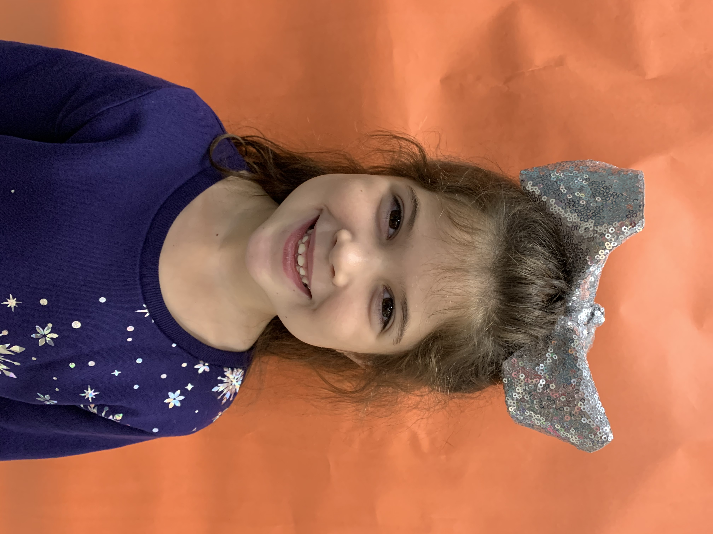
Meet Sadie Plunkett

Sadie is 6 years old and she has one brother. Sadie’s favorite color is blue and she likes to eat macaroni and cheese. Sadie’s favorite part of kindergarten is coloring!

Please check the school’s website for upcoming events and important information. www.southern.k12.oh.us

