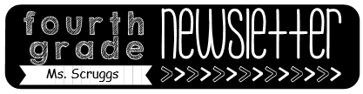

Reminders

-**Masks** need to be worn at school.

-October 26-30: Red Ribbon Week

**Mon: team jersey day**

**Tues: pajama day**

**Wed: Hawaiian day**

**Thurs: Western day**

**Fri: Book character day**

-Oct. 28: turn in your candy for Halloween bags

-October 30: Fall celebration (end of the day)

-November 3: Election Day

November 11: Math Case 21 test

October 26th -30th

Homework

Monday:

* Study the math study guide
* Study math facts

Tuesday:

* Study math facts

Wednesday:

* Order of operations worksheet

Thursday:

* Word problem worksheet

What we are learning…

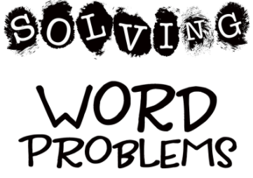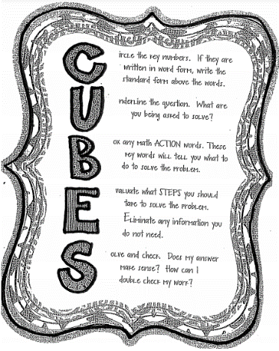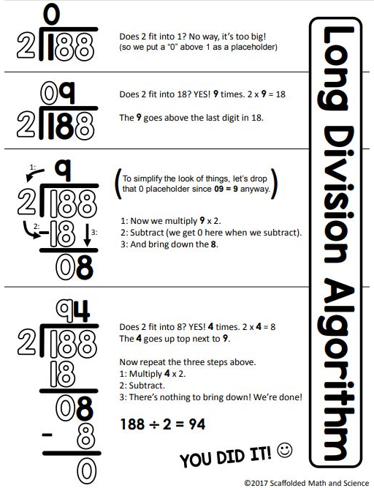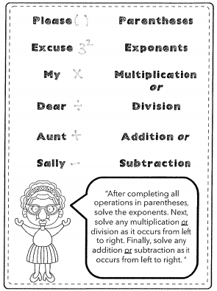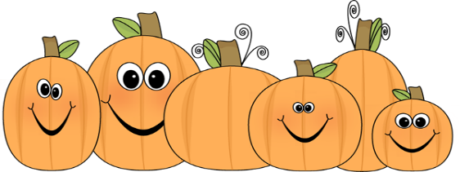

Tests/Projects

-Check my progress quiz 10/26

-Unit 4 assessment 10/27

-Timed Test 10/28