Science Assignments:
Monday, May 4, 2020
Title: Plant Cells and Photosynthesis PAGE #18 (L.5.3A.1)
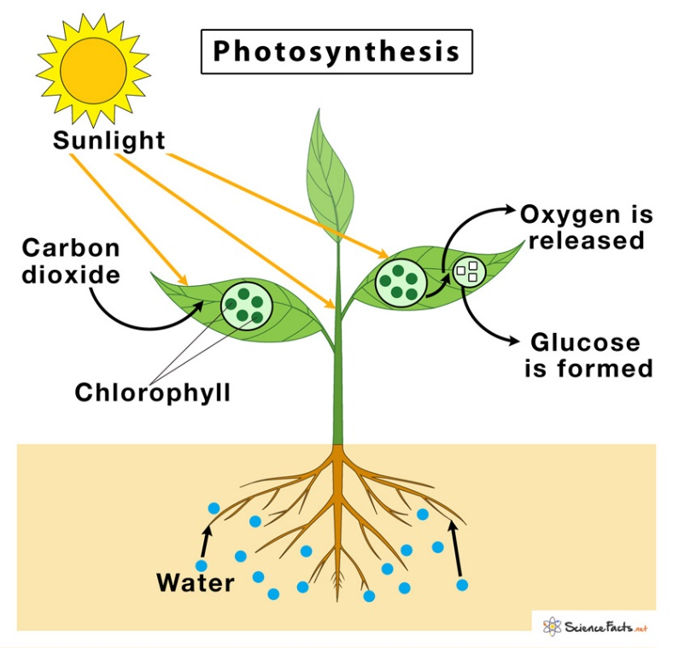
Directions: Photosynthesis is the process plants use to make their own food (glucose, a type of sugar) using energy from the sun. Plants take in carbon dioxide (CO₂) and water (H₂O) and make oxygen (O₂) and sugars (C₆H₁₂O₆). Watch the two Study Jams videos to learn more and complete the test yourself questions. Then draw, color (if you can), and label the diagram of photosynthesis in your science notebook.
Study Jams: Plant Cells
Study Jams: Photosynthesis

************************************************************************************************
Tuesday, May 5, 2020
Title: Thinking About Photosynthesis PAGE#19 (L.5.3B.2)
Directions: Foss Readings and Questions
Log in to FOSSweb and click on Living Systems; Student ebook; Interactive ebook. Read the following passages, then answer the questions that follow.
Choose ONE of these ways to answer the questions:
1. Write the questions and a short answer.
2. Write your answers in a complete sentence by restating the
question.

Passages to Read:
- “Nature’s Recycling System” pg 18-20
- “Producers” pg 23-24
- “The Carbon-Oxygen Cycle” pg 25-26 (answer questions at end of this passage)
*Don’t forget to submit your Biome Project to your teacher today!

************************************************************************************************
Wednesday, May 6, 2020
Title: Energy Roles PAGE #20 (L.5.3B.2)
Directions: Log in to FOSSweb to watch the video Food Chains. Then watch the one about predators and prey. Write these definitions in your science notebook on page 20.
VIDEOS:
FOSSweb: click on Living Systems; Streaming Videos; Food Chains
How Jungle Predators Get Their Prey
1. Producer: an organism, such as a plant or algae, that makes its own food. (example: grass, phytoplankton)
2. Consumer: an organism that cannot make its own food. Consumers eat other organisms for energy. (example: elephant)
3. Decomposer: an organism that breaks down dead plant and animal material into simple chemicals and returns nutrients to the soil. (example: bacteria, fungi)
4. Predator: an animal that hunts for food. (example: lion)
5. Prey: an animal that is hunted and eaten. (example: zebra)
6. Carnivore: an animal that eats other animals. (example: hawk)
7. Herbivore: an animal that eats plants. (example: rabbit)
8. Omnivore: an animal that eats both other animals and plants. (example: raccoon)
9. Food chain: a model of feeding relationships between organisms in an ecosystem. Arrows show the flow of matter and energy fromone organism to another. *Starts with the sun!*
10. Food web: ALL the food chains in an ecosystem.

************************************************************************************************
Thursday, May 7, 2020
Title: Food Chains and Food Webs PAGE #21 (L.5.3B.2)
Directions: Watch the YouTube video about how energy flows through an ecosystem.
Food Chains Compilation: Crash Course Kids
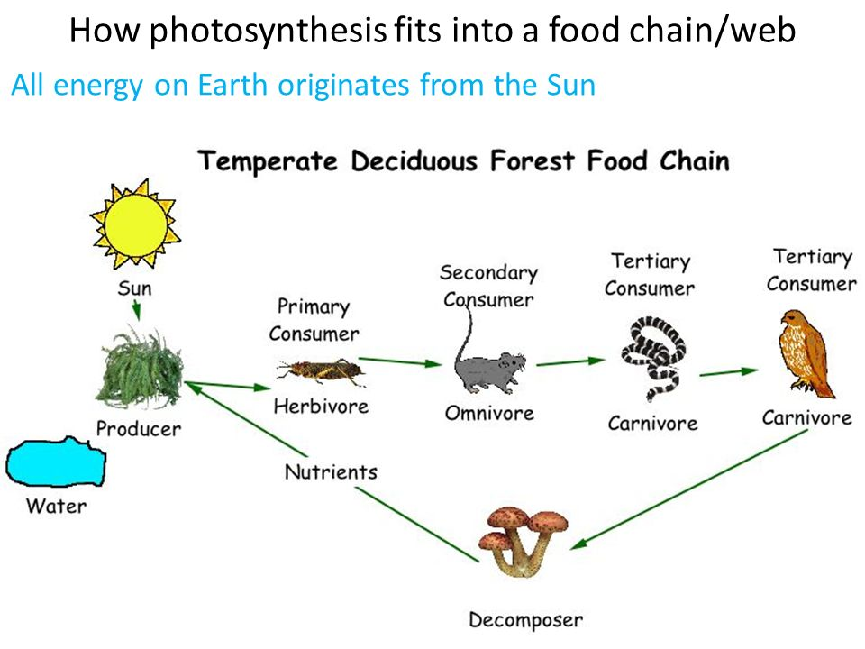
Here is an example of a backyard food chain. Draw, color (if you can) and label this model in your science notebook. Then write the descriptions of each feeding level.

1.
6.
5.
4.
3.

2.

7.

1. Food chains begin with the SUN because it is the energy source for all organisms. The arrow shows the direction that energy flows: from the sun to the plant. *The direction of the arrows is important!
2. Producers use the energy from the sun to make food during photosynthesis. The next arrow points away from the plant because the matter and energy from the plant flow to the grasshopper when it eats the grass.
3. The grasshopper is called a primary consumer because it is the first eater in this food chain. Primary consumers feed on producers. The grasshopper is also an herbivore because it eats only plants. It is also prey because it is hunted and eaten by the mouse. The arrow points from the grasshopper to the mouse to show that matter and energy from the grasshopper flow to the mouse when it eats the grasshopper.
4. The mouse is called a secondary consumer because it is the second eater in this food chain. Secondary consumers feed on primary consumers and can be omnivores or carnivores. The mouse is an omnivore because it eats both plants and other animals. The mouse is both a predator (it hunts and eats the grasshopper) and prey (it gets hunted and eaten by the snake) in this food chain. The arrow points from the mouse to the snake because matter and energy from the mouse flow to the snake when the snake eats the mouse.
5. The snake is called a tertiary consumer because it is the third eater in this food chain. Tertiary (pronounced “ter-shee-ary”) consumers are carnivores because they feed on secondary consumers, which can only be other animals. The snake is a carnivore because it eats the mouse. It is also both predator and prey. It hunts and eats the mouse, but is also hunted and eaten by the hawk. The arrow flows from the snake to the hawk because matter and energy from the snake flow to the hawk when the hawk eats the snake.
6. The hawk can also be called a tertiary consumer because it could eat the mouse instead of the snake. It could also be called a quaternary consumer because it is the fourth eater shown here. Quaternary (pronounced “qwa-ter-nary”) consumers are carnivores and predators at the top of the food chain. They are also called apex predators because there is not another animal that eats them. Matter and energy from the hawk flow to decomposers which break down the materials the hawk is made of once it dies. Those materials are returned to the ecosystem.
7. Decomposers, such as the mushrooms, sit outside of the food chain and touch all feeding levels. When organisms die decomposers break them down into basic nutrients and return those nutrients to the ecosystem. Those nutrients are used by producers.
*Important note: All organisms rely on the sun for energy, either directly (producers) or indirectly (consumers and decomposers).

************************************************************************************************
Friday, May 8, 2020
Title: Energy Flow in an Ecosystem PAGE #22
Directions: Choose one (or more) of the following activities to complete. If you choose a Generation Genius video, you will complete the Exit Ticket as you have been doing in your science notebook. If you choose Study Jams, take the quiz and record your results in your science notebook, also, as you have been doing.
Generation Genius: Food Webs
Study Jams: Food Chains
Food Webs

