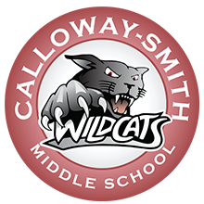

CALLOWAY-SMITH MIDDLE SCHOOL
2020-2021 MEET THE TEACHER
6th GRADE- TUESDAY, OCTOBER 13, 2020
8th GRADE- WEDNESDAY, OCTOBER 14, 2020
7th GRADE- THURSDAY, OCTOBER 15, 2020
Times- 5:30 p.m.

Webex Link-
https://mcpss.webex.com/mcpss/e.php?MTID=m15918e7ac829092c3a65992d53aeb5ed
Parents please download the Webex app prior to the meeting.
Nedra Payton, Principal (8th)
Kershawna Harden, AP (7th)
Derrick Gray, AP (6th)
LaDonna Royster, Title I Facilitator
Mary Jones, Counselor

