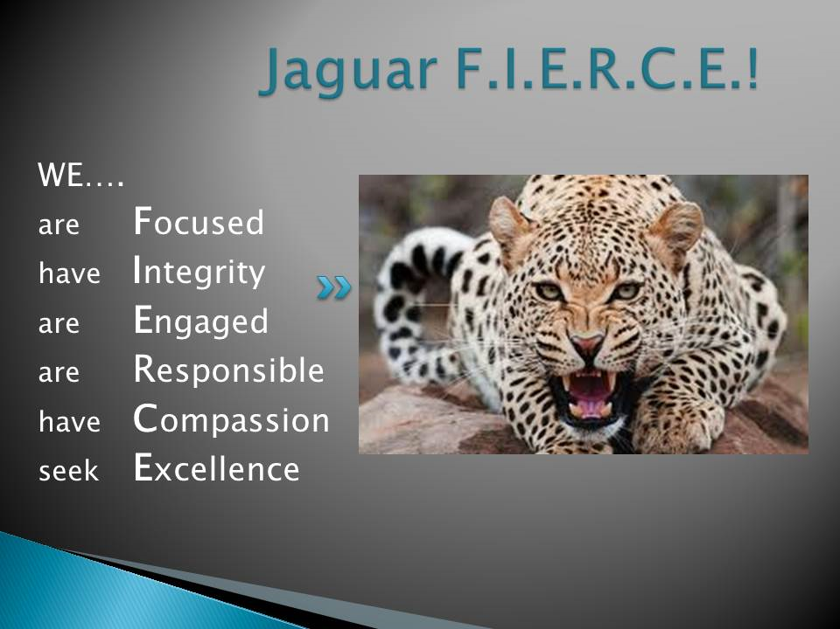
,

Goal 1: Provide high quality instruction
Action 1: Develop and execute strategic plans to demonstrate growth and increased achievement in Math, Language Arts, Science, and Social Studies on the College and Career Readiness Performance Indicator.
Action 2: Create diagnostic, formative, and summative assessments during subject area PLC’s to guide and differentiate our Standards-based instruction.
Action 3: Provide student-centered learning, critical thinking, problem solving, and literacy opportunities, which meet the needs of individual learners and their different learning styles through the work of Professional Learning Communities (PLC’s).

Goal 2: Provide opportunities for all students to be successful
Action 1: Ensure a systematic approach to identifying, targeting, and remediating/accelerating students' learning based on readiness using common formative assessments, Multi -Tiered Systems of Support and researched-based strategies.
Action 2: Facilitate training in the continued implementation of progress monitoring through the RTI process.
Action 3: Recognize the impact of parental involvement in student success and be more proactive about informing, recruiting and engaging our stakeholders through electronic and social media.
Action 4: Implement Jag Academy for enrichment, intervention, and remediation for ALL students, by standard and by skill.

Goal 3: Provide a culture that encourages personal responsibility and ownership while building capacity for decision making that leads to success.
Action 1: Model expected behaviors and the character traits of Jaguar FIERCE.
Action 2: Implement PBIS through our Jaguar FIERCE behavior plan. Facilitate decision making by providing instructional support.
Action 3: Empower students to reflect and modify their behaviors as needed so they may engage successfully in all settings and acquire outcomes to meet personal goals.
Action 4: Recognize students through PBIS Rewards for displaying the character traits of Jaguar FIERCE.

Goal 4: Provide/Ensure continuous improvement through professional development and opportunities for growth.
Action 1: Plan, construct, and facilitate vertical alignment in all academic areas through bi-weekly PLC meetings and monthly subject area meetings.
Action 2: Ensure best practices through professional development and growth using student performance data, common assessments, and teacher feedback data as our guide.
Action 3: Provide consistent implementation and support of organizational structures and procedures through grade-level meetings.
Action 4: Identify and utilize our master teachers to lead our site-based professional learning based on school goals, staff needs, interests, and best practices.

