Purchase your Daniel Pratt Elementary Yearbook today!

Student Name ______________________________________________________

Grade 1 2 3 4 5 6 (circle one)

Homeroom Teacher _________________________________________________

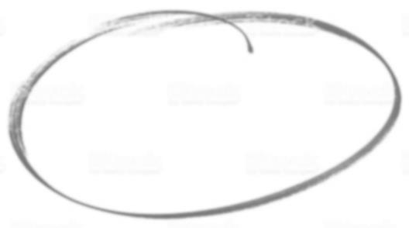

Yearbook $28 Total Enclosed $_____________

Please return this order form and payment in an envelope labeled “yearbook” to your child’s homeroom teacher by Wednesday, March 24th.

**If ordering more than one yearbook, please use a separate form for each student. You may place all forms in one envelope and write one check. Make checks payable to DPES.

ONLINE ORDERING: Visit www.YearbookOrderCenter.com Use order number 859

If you have any questions please contact the Yearbook Staff at dpes.yearbook@acboe.net or 334-361-6400.

