MILLER COUNTY HIGH SCHOOL CTAE PATHWAYS
AGRICULTURE PATHWAYS

Plant & Landscape Systems
- Basic Ag Science
- General Horticulture & Plant Science*
- Nursery & Landscape
Horticulture & Animal Systems
- Basic Ag Science
- General Horticulture & Plant Science*
- Animal Science Biotech

Ag Leadership Animal Production
- Basic Ag Science
- Agribusiness Mgt & Leadership
- Animal Science Biotech*

Ag Leadership Horticulture
- Basic Ag Science
- Agribusiness Mgt & Leadership
- General Horticulture & Plant Science*

WORK BASED LEARNING AGRICULTURE
(BY INVITATION ONLY 11TH/12TH)

9th Graders are limited to Basic Ag Science prerequisite to all other ag courses

Courses that can be utilized as a fourth science are indicated with an *
Vision Statement: Miller County Pirates uphold the highest ethical standards and moral values and believe they can achieve excellence in their school and community.

Business and Technology Pathway
- Introduction to Business & Technology
- Business & Technology
- Business Communications

Introduction class is a prerequisite to all other classes
8th grade offering: Foundations of Business Administration
Health Care Pathways

Therapeutic Services/Allied Health/Medicine
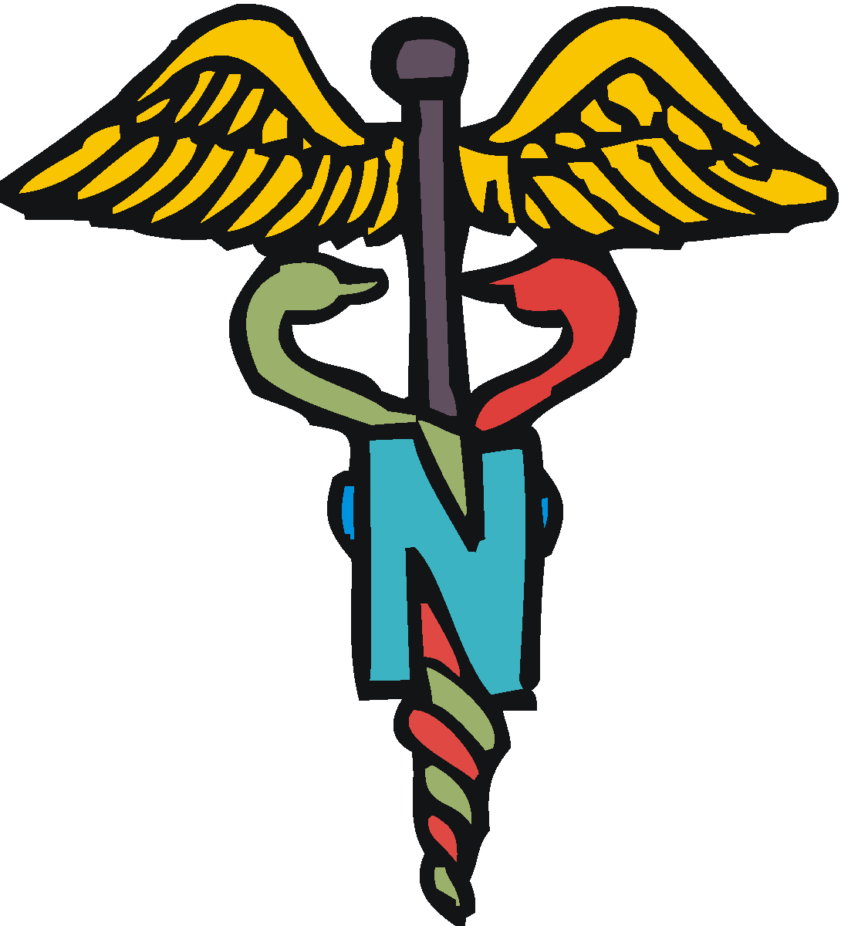
- Intro to Healthcare Science
- Essentials of Healthcare*
- Allied Health and Medicine
Introduction class is a prerequisite to all other classes
Nurse’s Aide Pathway is offered on MCHS campus and taught by our health science instructor

