
KA Newsletter


Mrs. Blatch
Email: kimberly.blatch@southern.k12.oh.us

2/3/20-2/7/20
1

Words to Practice
yellow
blue
green
red
purple
pink
orange
black
brown
gray
white
the
a
and
are
to
do
is
his
as
has
was
we
she
he
be
me
you

Notes & Reminders
- The PK-2 second nine weeks awards assembly will be held on Wednesday, February 5th at 9:30 in the elementary gymnasium. Awards will be given to the November and December Student of the Month recipients as well as to students who had perfect attendance during the first and second nine weeks.

- We will celebrate our 100th day of kindergarten on Friday, February 7th. Students are encouraged to dress as if they are 100 years old!

- Please make sure to practice trick/sight words (listed on each newsletter) regularly with your child. If you are looking for other skills to review at home, this nine weeks students will be expected to read and write numbers to 20, count to 100, write their last names, and recite their home addresses. When working on trick words and numbers with your child, try to make it as fun as possible! For example, try making a memory/matching game using our trick words.

Weekly Focus

- Math: Counting to 100 by ones and tens

- Writing: Sentence mechanics (begin with a capital letter, leave spaces between words, end with punctuation)

- Phonics: CVC (consonant-vowel-consonant) words

- Trick Words: you

Specials
Monday: Gym
Tuesday: Technology
Wednesday: Music
Thursday: Art
Friday: Music

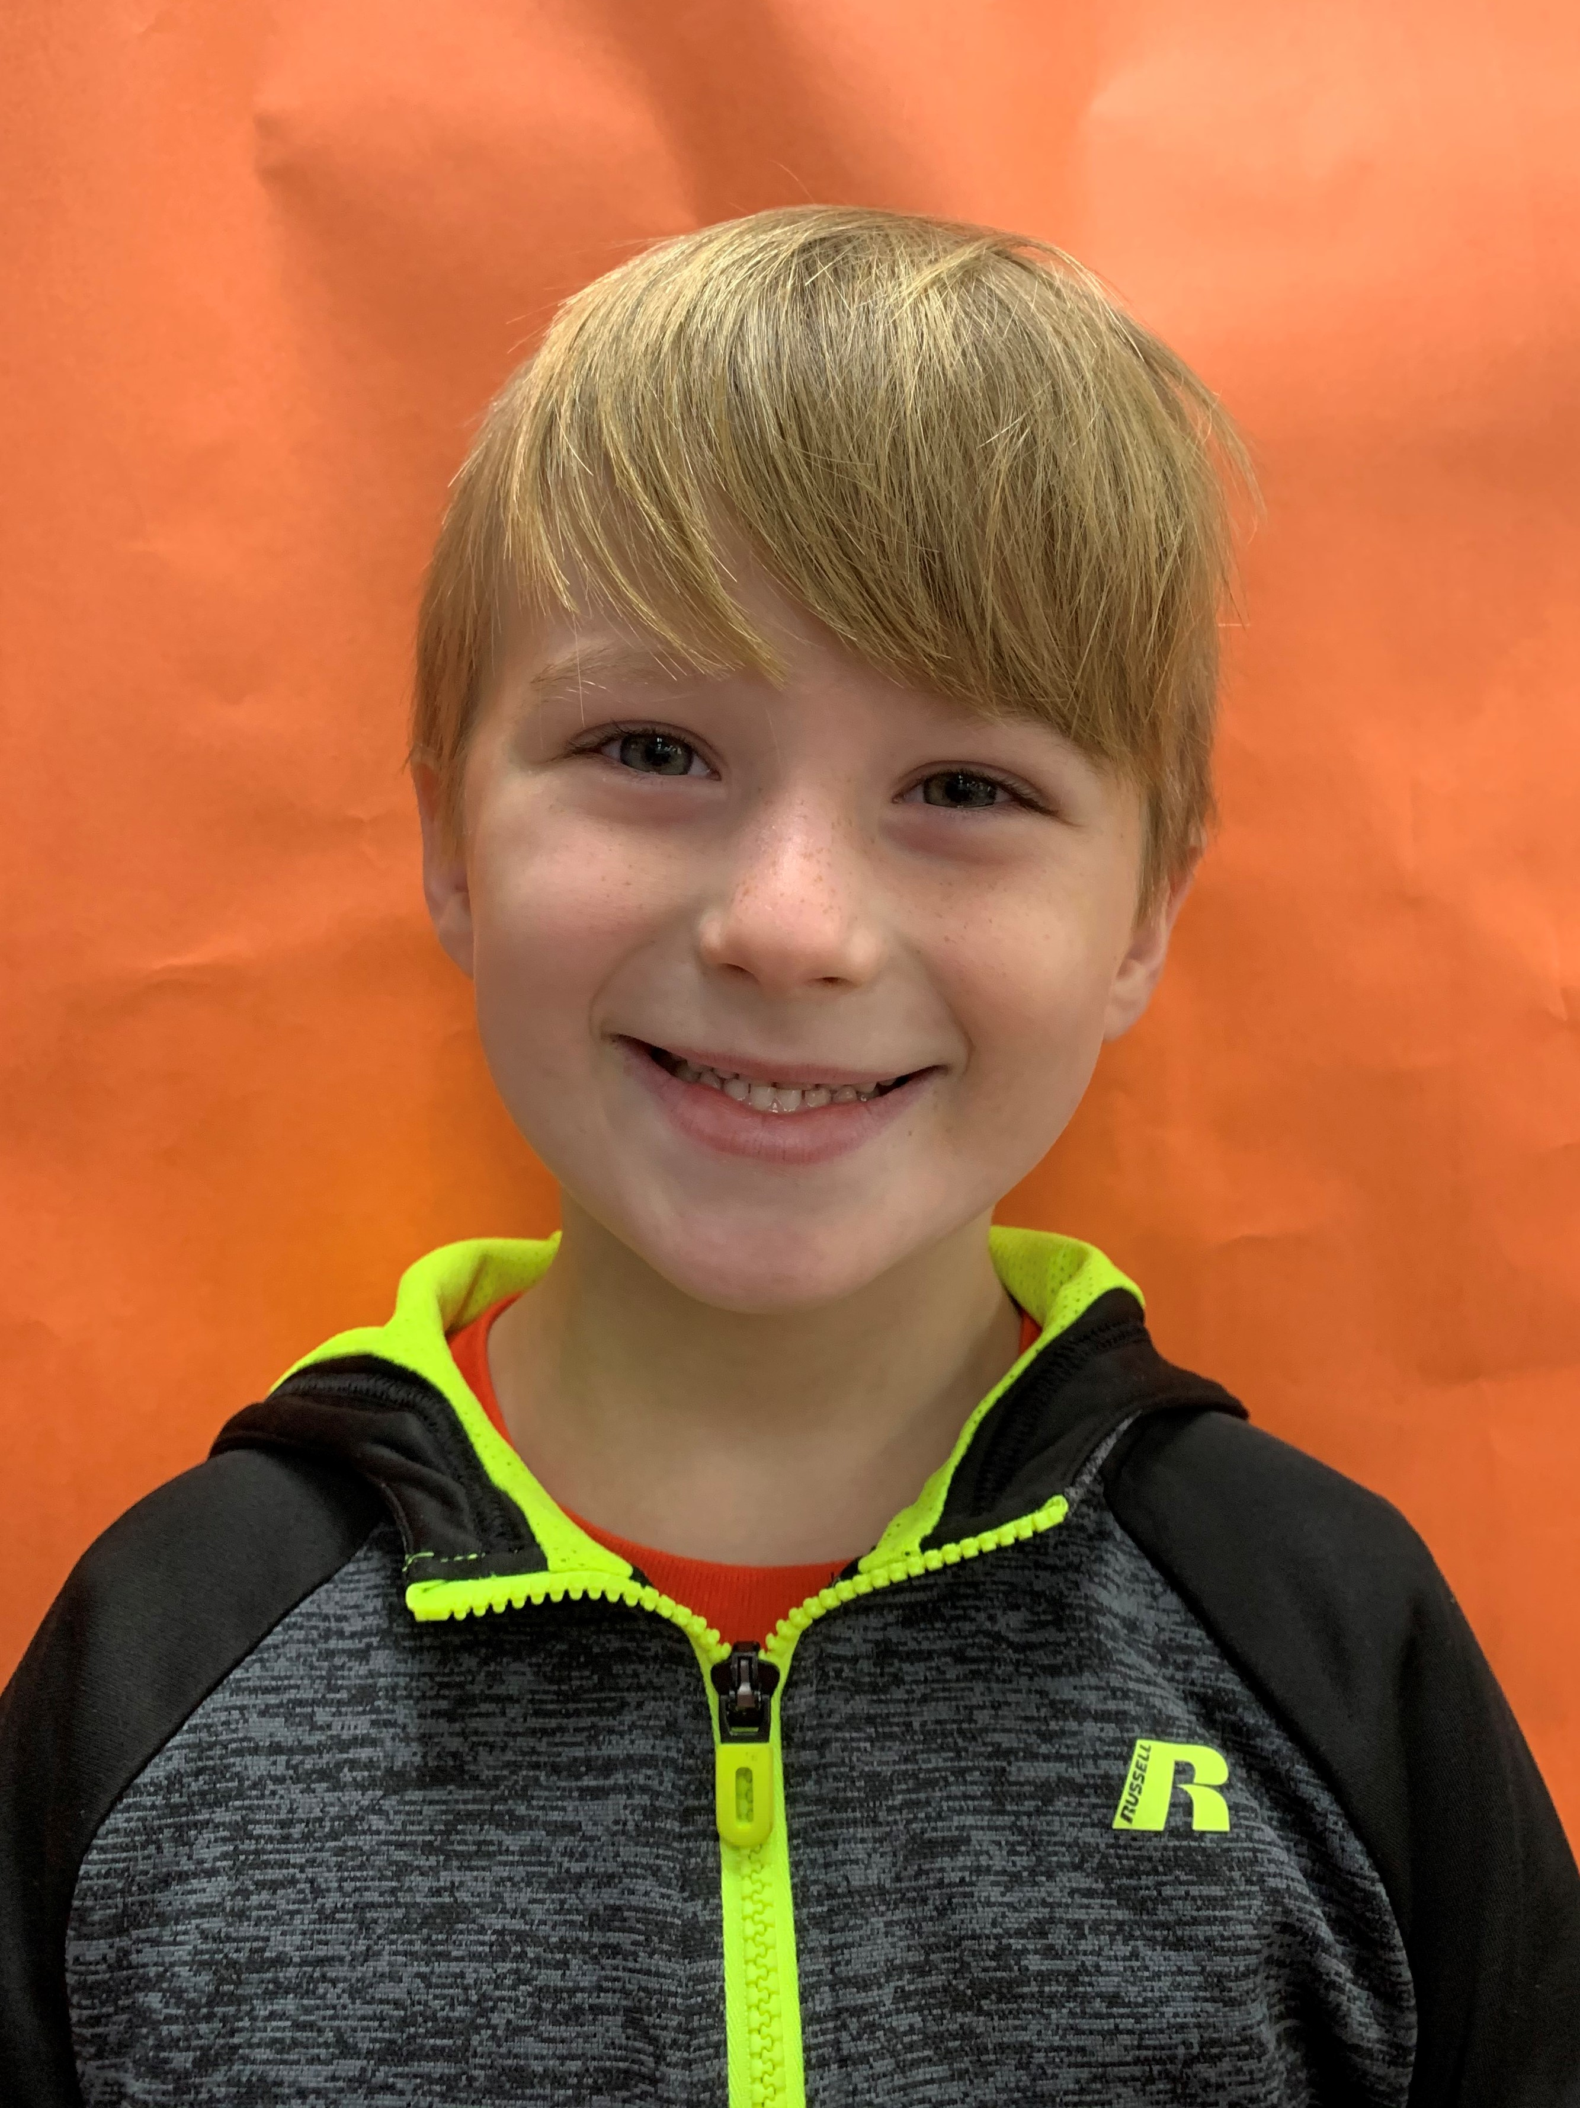
Meet Skyler Smith

Skyler is 6 years old and he has two sisters. Skyler’s favorite color is blue and he likes to eat pizza. Skyler’s favorite part of kindergarten is counting!

Please check the school’s website for upcoming events and important information. www.southern.k12.oh.us

