Reader’s Oath

I promise to read
Each day and each night,
I know it’s the key
To growing up right.
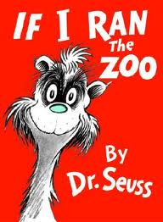
I’ll read to myself,
I’ll read to a crowd,
It makes no difference
If silent or loud.

I’ll read at my desk,
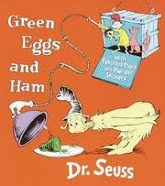
At home and at school,
On my bean bag or bed,
By the fire or pool.

Each book that I read
Puts smarts in my head,
‘Cause brains grow more thoughts
The more they are fed.

So I take this oath
To make reading my way
Of feeding my brain
What it needs every day.

~Debra Angstead

