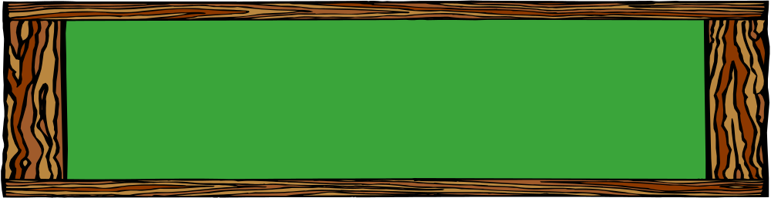
KA Newsletter


Mrs. Blatch
kimberly.blatch@southern.k12.oh.us

9/9/19-9/13/19

Notes & Reminders
- Students should wear blue on Wednesday.

- Scholastic book orders are due on Friday, September 20th.

- Please continue to have your child wear his or her name tag to school this week. In addition, please continue to practice your child’s ID number (listed on the name tag) in order to decrease the amount of time children spend waiting in the breakfast and lunch lines.

- We are still in need of Ziploc bags (snack, sandwich, and gallon sizes) and paper plates for classroom use. If you would like to donate these items, we would appreciate it!

Skills & Concepts
Students will...
- Practice reading and writing names RF.K.1
- Identify the names and sounds of t, b, & f RF.K.3
- Isolate beginning and ending sounds RF.K.2
- Express stories through illustrations W.K.2
- Identify the word “blue” and name objects that are blue RF.K.3
- Count quantities of 0-5 K.CC.5
- Recognize and write 0-5 K.CC.3
- Compare and order 0-5 K.CC.7

Specials
Monday: Gym
Tuesday: Technology
Wednesday: Music
Thursday: Art
Friday: Gym

Words to Practice
yellow
blue



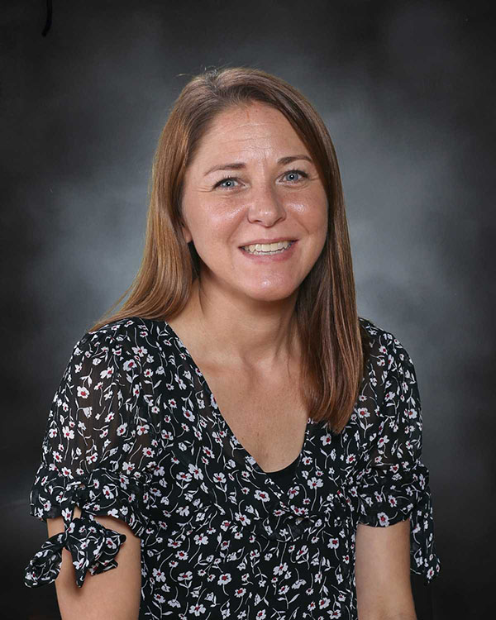
Meet Mrs. Rauschenberg

Mrs. Rauschenberg is a graduate of West Liberty University. She has been teaching for 17 years and currently works as the K-1 Intervention Specialist. Mrs. Rauschenberg has two boys, ages 10 and 14. She enjoys reading, watching her boys participate in karate and track and field, and spending time with her family and friends. Mrs. Rauschenberg visits our classroom to teach Fundations and literacy centers.

Please check the school’s website for upcoming events and important information. www.southern.k12.oh.us

