Log in to your computer

Step one:

Go to http://acboe.schoology.com/

Step two

Log in to Schoology

Step three: Click on the word “Courses”
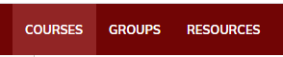

Step four:

Click on “My Courses”
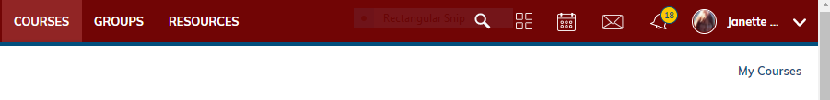
tep
Step five
Click “Join A course”

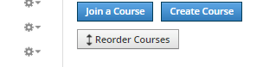
Step five: Click on “Join a course”

Step six
Paste in the following Access Code: 7MN4-VVZW-FGCZ9
Step seven
Click on “Courses” again
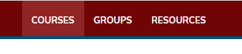

See next page

Step Eight
Find the course you just joined and click on it. . It is called “PHS Schoology Training for Students”
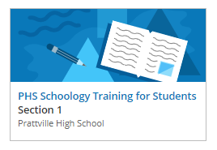
Click on this Green Folder
Step nine
Find this information on your resulting page
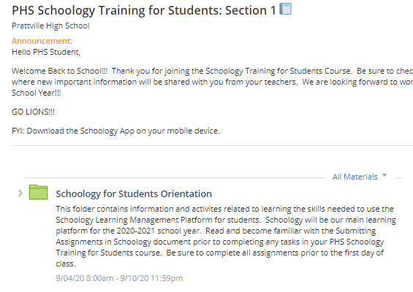
See next step below

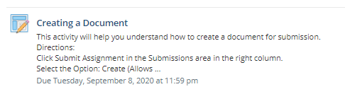
Step Ten: click on this activity

Step Eleven:
Then,… follow the related
Instructions exactly! The instructions will walk you through how to create your own document by first clicking the submit button and then clicking “Create”, typing your information..and then clicking submit again. Yes..I want you to do exactly what it says …this process gives you a chance to practice using Schoology. .
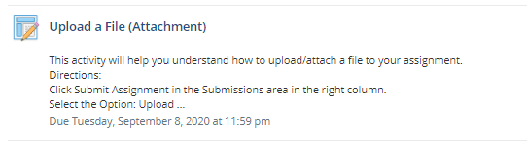
Step Twelve:
Click on this activity

Then,… follow the related
Instructions exactly! The instructions will walk you through how to attach a file. Yes..I want you to do exactly what it says …this process gives you a chance to practice using Schoology.

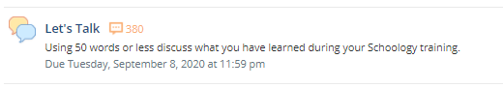
Step thirteen
Click on this activity
Then,… follow the related
Instructions exactly! The instructions will walk you through how to post a comment. Yes..I want you to do exactly what it says …this process gives you a chance to practice using Schoology
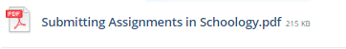
Step fourteen
Click on this
(which will be located as the first activity) and read about integrating the Google Drive.

