Language Lesson From March 26 & 27

Reading
Read about American alligators! Click here to read! What did you learn about alligators? Think about characteristics of real American alligators. Try to remember interesting facts you found while reading the article. Click here to watch the tutorial on how to access the passage.

Listening
Click here to listen to the story of Snappsy the Alligator. Listen for figurative language and words you may not know. Think about Snappsy's characteristics. How are he and real alligators similar and different?

Writing
Write about what you listened to. What kind of figurative language did you find? How did the figurative language affect the structure of the book. Compare and contrast Snappsy's life and characteristics with the life and characteristics of a real American alligator.

Speaking
Find a friend or family member and talk about the article and the book. Talk to them about the figurative language you found and how that adds to the structure of the book! Discuss how you compared and contrasted Snappsy and a real American alligator.
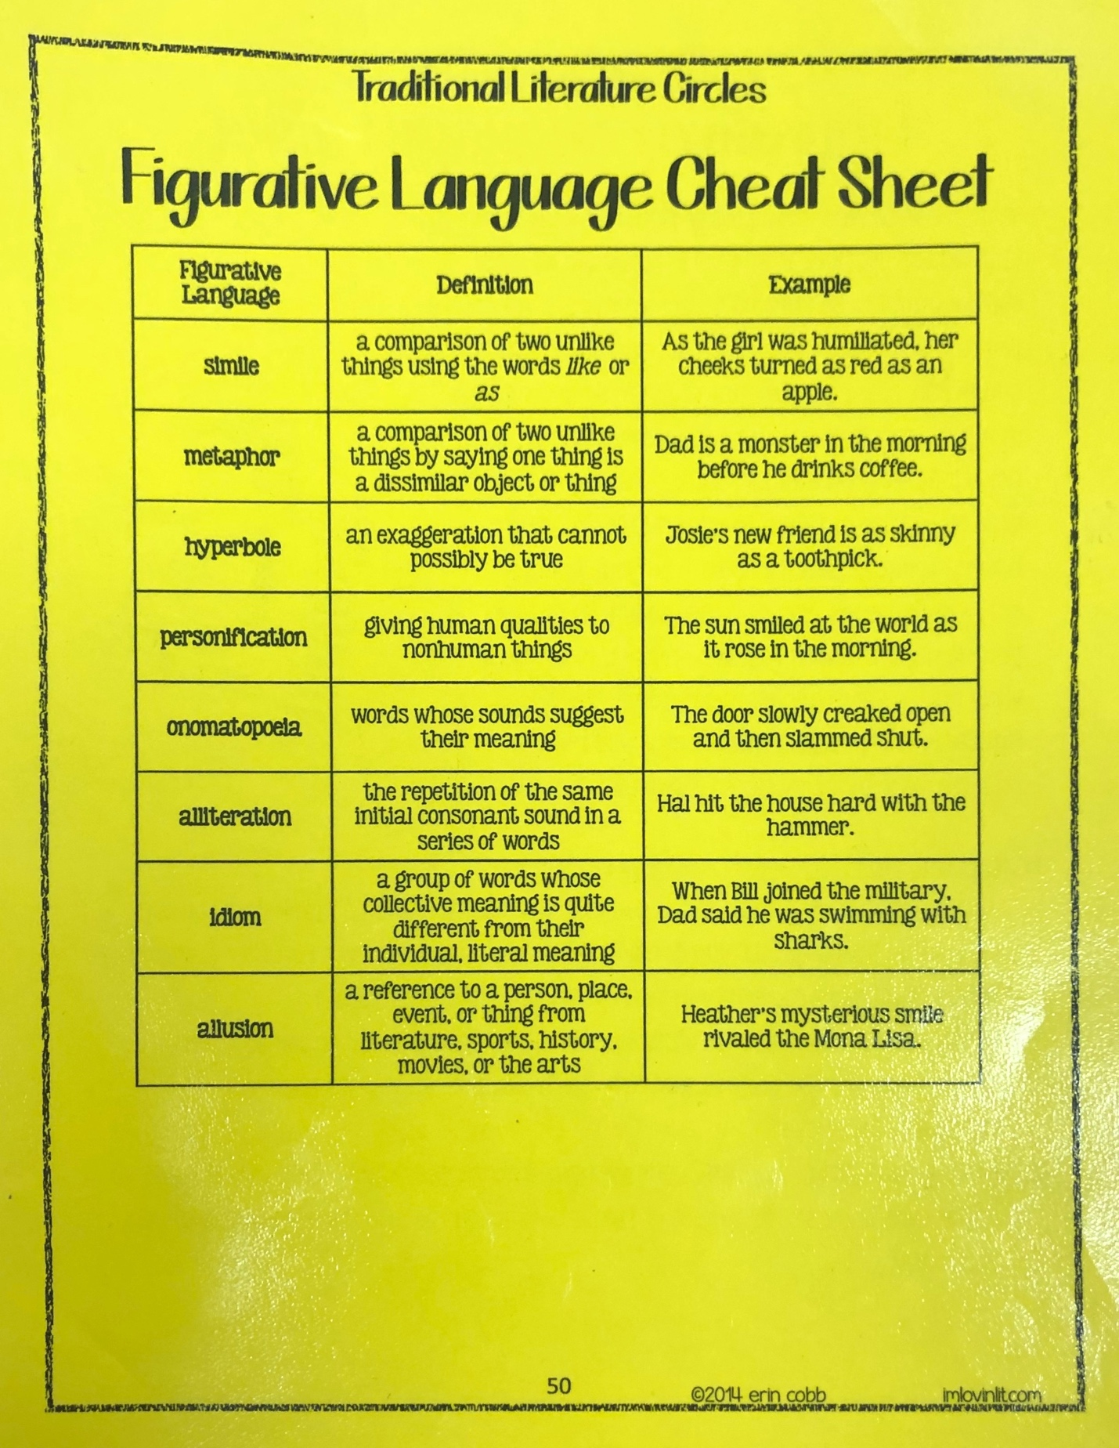

Language Lesson From March 30 – April 3

Reading

Read about the Seven Wonders of the World. Click here to read. Try to think about what it would be like to actually visit these places. Try to remember some key details about each wonder.
Listening
Click here to go on and listen to the virtual field trip! Remember to turn on the narration with the wheel in the top left of the video screen. Click here to watch a video with more facts! Try to find some different key details than the ones you read about!
Writing
Try to find and write 7 different facts for each of the seven wonders! Look back at the article you read and look through the virtual field trip again! Remember not to copy exactly what the author wrote and use quotation marks!
Speaking
Find a friend of family member and talk about what you saw! Tell them about your favorite wonder. Tell them which one you would like to visit and why! Ask them which one they would like to visit.

Language Lesson From April 26 – May 3

Reading
Click here to read a story about someone your age going to space! What do you think Eva's new life in space will be like? Why do you think she and her family are going to space? Find some words you do not know and look them up! Click here to watch the tutorial on how to access the passage.
Listening
After reading, click here to watch this video about our solar system! Have fun learning about the planets that are all around us! Who is at the center of our solar system? How many planets are there? What is the order? Find some other important facts about our solar system!
Writing
Click here to go to Nasa's website. Here you will be able to look at what Nasa saw on your birthday! You can write about what inferences (or guesses) you have for Eva and her family on their journey to space. You can write about what you learned from the solar system video. You can write about what Nasa saw on your birthday. Or! You can write about it all! Use the boxes on my website to send me what you write! Put your name as the subject!
Speaking
Click here to send me a FlipGrid telling me about what you just learned! Would you want to take your family to space like Eva's family? Where would you go if you could go to any of the planets in our solar system? What did you think about what Nasa saw on your birthday? What else would you want to know or learn about space?

