Mrs. Daniel’s Newsletter
March 15-19, 2021
Vocabulary, Spelling (un-, re-, pre-, dis-), Grammar (singular and plural pronouns),
Reading Skills (cause and effect) Tests on Friday

Story:  “Carl the Complainer”  by Michelle Knudsen  Phonics/Fluency:  prefixes  un-, re-, pre-, dis-  Text-Based Comprehension:  cause and effect, visualize  Grammar:  singular and plural pronouns |  | Selection Vocabulary Words (Students will be tested on these):  - annoy – to bother or make someone feel upset or angry  - complain – to say that you are unhappy about something  - mumbles – speaking too quietly to be heard  - P.M. – letters that mean afternoon; P stands for post and M stands for Meridian which means “after midday”  - shrugs – to raise shoulders briefly to show you are not interested or do not know  - signature – a way to sign your name  Amazing Words  concern, persuade, pellets, pollute,  contribute, fragile, litter, release
Important Dates:  3/16- STEAM Zoom night @6p.m.  3/26-Special Snack/Spirit Day  3/29&3/30- e-learning days 3/31-4/2 Spring Break |  | Topic 11: 3-digit  We are beginning Topic 11 on 3-digit addition. Please help your child practice this skill each night at home in his/her homework packet.  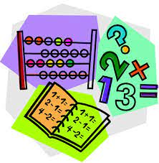  Homework Note:  Please make sure to work with your child on his/her  homework each night. The packet includes review  activities that will help your child each day in class.
Spelling Words:
- unsafe  - preheat  - rerun | - disappear  - unlock  - discolor |  | - rewind  - unpack  - unplug | - regroup  - preschool  - disagree

