What are we learning?
We want to keep things as simple as possible for all students. We have created the 3 R’s. This is what your child with internet at home can do every day.
3 R’s: Read/Reflex/ReadingEggspress
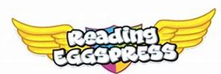
Reading Eggspress. This week we have books for you to read and online quizzes to complete.

Fiction Book: Toothless
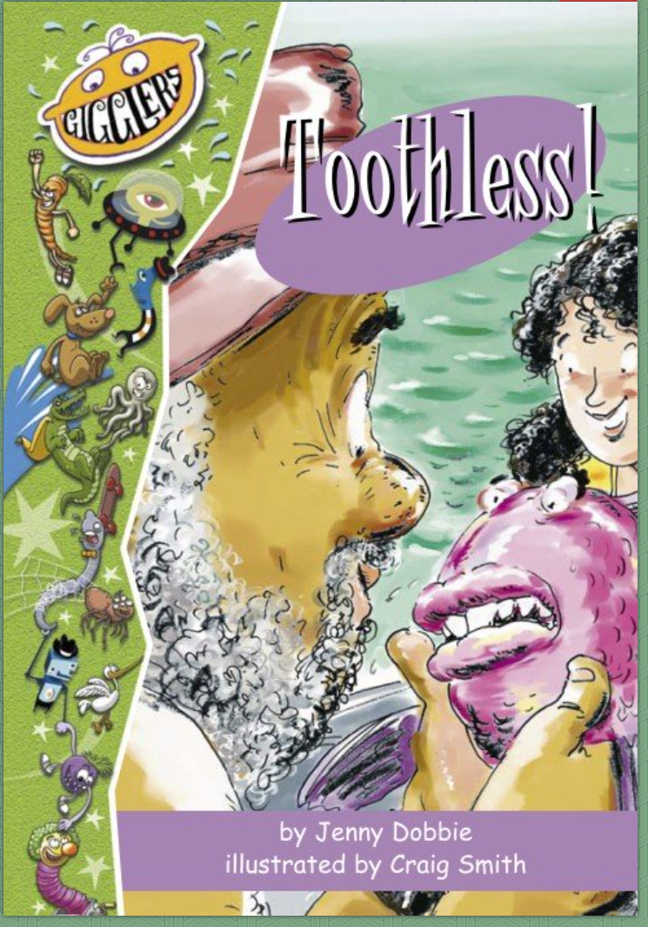
Non-Fiction Book: Plants that Bite Back
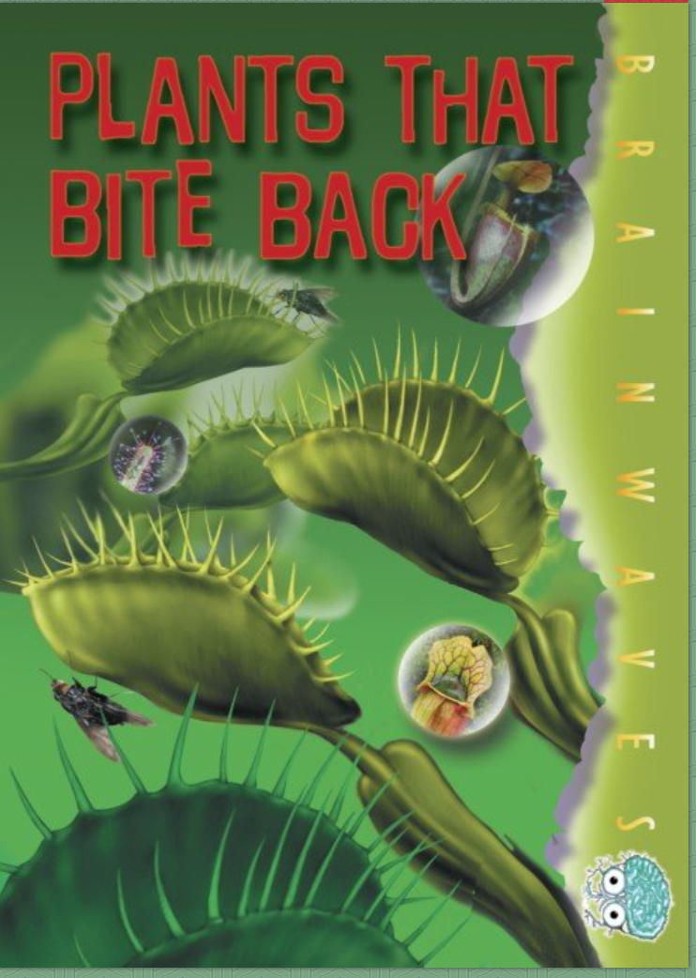

2nd Grade News

DCPS
April 20th-24th

Math Skills
😊Did you get a green light on Reflex today?
This week your teacher will post on their website:
- Word Problem of the Day
- 9 Box Review
Remember you can do this on notebook paper too.

Writing Prompt
In the book Toothless, Lucy’s inventions helped her family.

Write about something you might invent to help someone in your family. What would you invent and for who? What would your invention do to help out?

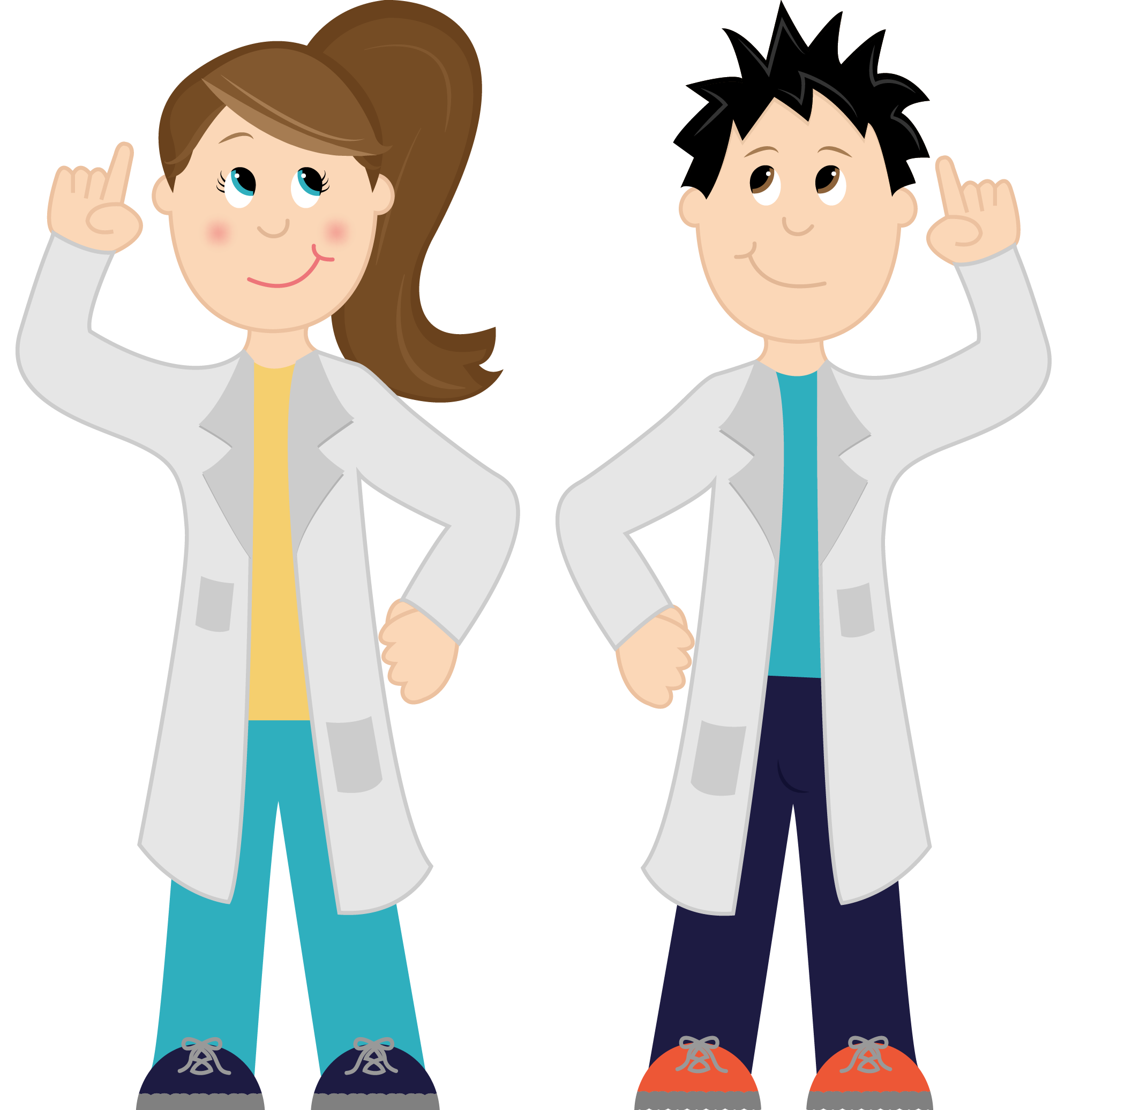

Phonics

Remember me
Please remember these are only suggestions to help maintain information that was previously taught in class. Your child can always choose a different book or activity from home to complete.
Website/Facebook:
Please look at your teacher’s website for more links and information. We have also created a DCPS 2nd Grade Facebook group that you can follow for more ideas and websites.

Comprehension Questions Parents Can Ask:

- Would you rather use Lucy’s invention “The Crazy Cleaner” or “Doggie’s Little Helper”?

- Why could you describe Lucy as a problem solver?

Comprehension Questions Parents Can Ask:

- List three facts about plants from the text.

- This book used photographs and illustrations. Why do you think that was done?
Videos for kids:
http://youtube.be/4yvUjwt2-jl (Carnivorous Plants for kids on YouTube)

http://youtu.be/tkFPyue5X3Q (How does a seed become a plant? SciShow Kids on YouTube)

https://youtu.be/3Gy_gts86jM (Why do we have baby teeth? By Scishow kids on YouTube)

