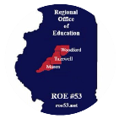

November 7, 2017
Principals’ In-service
Central Junior High, East Peoria, IL

- Welcome/Introductions

- 9:15 a.m. Brad Hutchinson
  - Illinois State University

- YCMTSU

- 9:30 a.m. - Carol Merna & Marcia Bolden
  - Center for Prevention of Abuse
    - PDF#1
    - PDF#2
    - PDF#3

- Courtney Lyons
  - Director of Professional Learning
  - AA & PD updates

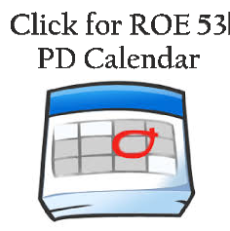
Administrator Academy #1448 Registration
Administrator Academy #1865 Registration
Administrator Academy #3002 Registration
ROE#53 – Admin Academies Date and Location

  - Common SIP days
  - Most Requested Professional Development

- 10:00 - Val Keen
  - Talent Assessment Inc.
  - PAES – Practical Assessment Exploration System

- Agenda Items

  - Updated Mandated Documents
    - Mandated & Recommended Trainings
    - Mandated Units of Study

  - Middle School Endorsements
    - Future of Middle Grades
    - New Endorsement vs. Subsequent

OLD:
18 Content Hours
3 hours Middle School Philosophy/Curriculum/Methods
+ 3 hours Educational Psychology
24 hours

NEW:
Complete Illinois Approved Program (5-8)
21 Content hours
3 Semester hours of content-specific methodology (ex: math)
Passing Content area tests
+ Passing General Middle Grades Test – only required if outside 4 core areas: math,
science, social science, language arts (in development)
*may be waived if Elementary/Middle Grades 110 test taken OR
*if person has taught 5 through 8 for at least one year
24 hours

*Bold- Removed for subsequent endorsements

- Teachers can apply for a middle school subject area endorsement through transcript evaluation under the current endorsement structure January 31, 2018. If they do not meet the requirements for that endorsement, they will have 2 full fiscal years plus the remainder of that current fiscal year to remove any deficiencies that they might have so that the middle school subject area endorsement can be issued.
- Anyone who currently holds a middle school subject area endorsement will be able to add a subsequent middle grade endorsement under the new endorsement structure that will take effect February 1, 2018 without needing to complete a state approved middle grade educator prep program.
- Beginning February 1, 2018, all new middle grade endorsements will require 21 semester hours of coursework which will include 3 semester hours of methods, plus the content area test.

**Networking and Break**

- Bus Trainings
  - Initial and Refresher courses

- Principal Round Table Discussions
  - ESSA
    - ESSA & ISBE
  - Student Growth (High School)
  - Teacher Licensure
  - 3 Circles Grant
  - Social Emotional Needs and Services

