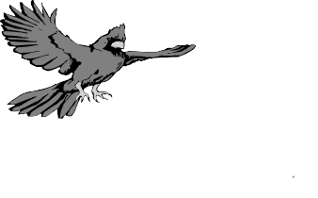
Nora Mae Hutchens Elementary School
Nora Mae Hutchens
Elementary School First Grade Supply List
$ 5.00 School Fee for Computer Supplies, First Aid and Mailings
$5.00
1st Grade Wish List

Students are required to have these supplies on hand DAILY
Quantity | Item
1 | Pair of Fiskars 5" scissors (blunt end)
4 | 24 count Crayola Crayons
12 | Elmer's Glue sticks
4 | Elmer's White School Glue
24 | Ticonderoga Pencils Pre-sharpened
1 | Crayola Classic Washable Markers 8 count
2 | 1 inch White Binders with Clear View Sleeve on Front
2 | Mead Composition Wide Ruled Notebooks
1 | Pack of 8 count Crayola Watercolors
1 | Clear Front Zipper Pouch (for 3 rinq binder)
1 | 8 count Avery two pocket plastic dividers (for 3 ring binder)
2 | Wide Ruled Spiral Notebooks
1 | Small Plastic School Box
2 | Plastic Folders with Brads and Pockets
1 | Package of Black Dry Erase Markers - 4 count
2 | Chubby Pink Erasers
4 | Clear plastic sheet protectors

PLEASE DO NOT PUT NAMES ON ANY OF THE ABOVE LISTED ITEMS

NO ROLLING BOOKBAGS/BACKPACKS

Please label all coats, sweaters, lunchboxes, etc.
Some items will need to be replenished during the school year!

Required $5.00 School Fee –for Computer Supplies, First Aid and Mailings

Items below requested but NOT REQUIRED (used every day)

1-One inch solid color Binder w/clear front for “Take Home” binder
4 boxes Kleenex
4 rolls paper towel
4 bottles of liquid hand soap OR a large soap refill
4 bottle of hand sanitizer
3 containers of Clorox wipes 1 pkg of Copy paper
1 multi-color pack Highlighters 2 containers of baby wipes
1 box of Ziplock gallon bags 1 box Ziplock sandwich bags
Paper Plates-white paper ones

NO ROLLING BOOKBAGS/BACKPACKS

PLEASE LABEL ALL COATS, SWEATERS, LUNCHBOXES, ETC.

