[](http://itunes.apple.com/WebObjects/MZStore.woa/wa/viewSoftware?id=329374595&mt=8)

**Story Kit** -Create an electronic story book by

writing text, and either drawing on

the screen or using your own photos.

Record sound effects too!

[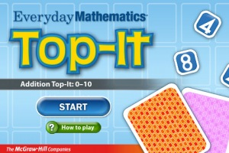](http://itunes.apple.com/us/app/everyday-mathematics-addition/id413312885?mt=8)[**Everyday Mathematics Subtraction Top-It**](http://itunes.apple.com/us/app/everyday-mathematics-subtraction/id425203268?mt=8&partnerId=30&siteID=uIXydSSmUKA) **–**

Practice and reinforce 2-digit subtraction

and number comparisons.

**Stack the States** – get the kids involved with this

educational, adorable game that combines the elements

of history, geography and a puzzle game (a bit like Tetris).

Stack the States quizzes you on information about the states,

such as capitals, shapes, mottos and location, among other

subjects. Get the questions correct and you drop the state to

the bottom of the screen. Stack the states above the finish

line to achieve new levels and unlock new states.

**Toy Story** Read-along is a free

interactive eBook from Disney (Toy

Story 2 and 3 cost £5.49 each)

The application can either read the

story to you whilst highlighting the

words or you can record your own

voice reading the story.Children can record

their own voice reading, and either listen back or

give it to another pupil whoprovides peer feedback on it.

Use 'Hinge' questions to assess

understanding. Instead of having the usual

multiple choice questions with

one right answer and the others

as incorrect, use each answer to

refer to a particular level of

understanding.

For example, answer 1 may be

a 'B' grade answer, answer 2

may be a 'C' grade. Use a tool

like **eClicker** (free)to aggregate the

scores and feedback to students. Teacher **eClicker Host** version $9.99

**Let’s Name Things Fun Deck**

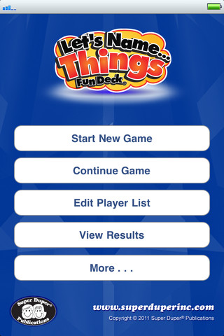This colorful vocabulary App for the iPhone®,

iPad®, and iPod touch® has all 52 illustrated

picture cards (plus audio of each card text) from

the Let's Name Things Fun Deck® by Super Duper®

Publications. Select the cards you want students to see,

and have them name items to practice vocabulary,

categorizing, and thinking skills. The prompts include

statements like, “Let’s name… things that live in the ocean.”

and “Let’s name… things you’d take on a trip.”

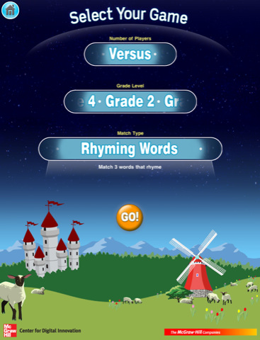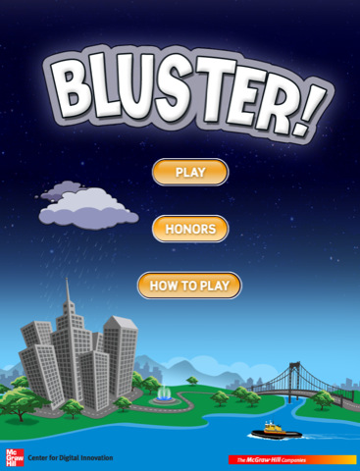**Bluster** - This word matching game develops vocabulary and word understanding for school-aged children, or anyone brave enough to battle the elements.

 Use the iPad as an expensive mini whiteboard.

Install a painting app such as the free **Doodle Buddy.**

Students can then use the iPad to draw their answers to

questions as they would on amini-whiteboard, but with less

mess and no need for pens. The app can also be used in

MFL when doing description -iPad in pairs, one person

describes hair and eyes in the target language, the other

draws what they hear. Free

**Pirate Treasure Hunt**

This game is a lot of fun! Pirate Jack is in

a bit of trouble and needs your help to

hunt for treasure. The game begins with

a spelling game to rescue Pirate Jack.

Once Pirate Jack is free, you explore an

island with him and complete 8 tasks that

involve numeracy, literacy and science

concepts. It's a little old for my Reception class, but

it has a lot of potential with older children.

But for now, I'll just play the game at the

weekends!

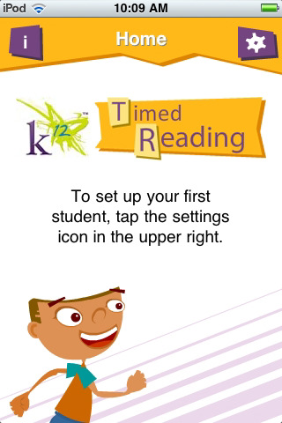**K12 Timed Reading Practice**

As the child is reading the short, timed

stories. the app tracks and gives a ‘words

per minute ‘reading result and also lists

the percentile the child is reading above or

below his class level . I, however, use it

for formative assessment by highlighting

words or sounds on my printed copy of

the story to work on later with the child.

A good assessment tool as well as an app for improving

literacy skills and fluency

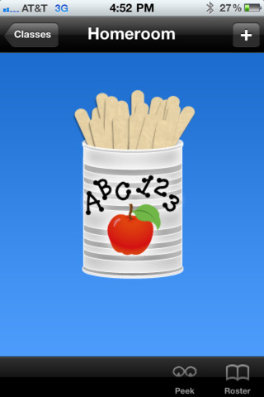 **Stick Pick** by Buzz Garwood (sixth grade teacher

in the Corona-Norco Unified School District)

"Stick Pick is an iPhone / iPod Touch / iPad “teacher tool”

application that allows you to randomly

(or intentionally) draw astudent’s name

from an on-screen can of popsicle sticks -- but that’s

just the beginning. You determine the mode and

level of difficulty for each learner, and then, every time

that student’s stick is drawn, you’ll be shown

over a dozen Bloom’sstyle question stems -- uniquely

tied to your learner’s individual ability level!" $2.99

 **Emoji Free**

These emoticons will download to

your iPad and can be added as an

international keyboard through the

settings. Students can use these to

make creative stories and express

their ideas with images.

http://appsfire.com/inc/images/appdealsIcon_carousel.png**Appsfire** **free** is the best way to discover the greatest apps

- it's your personalized App Store. Save money while buying apps:  
 App Deals brings you the hottest deals on top apps.

 **Socrative** ( you will need to download teacher version and students will use student version on either student Ipad or Smartphone) **Free**

Description

Socrative brings smart clickers, student response and ease of use to a whole new level. Be engaged for the entire class with educational exercises and games. See all your classmates’ ideas in real time and interact with the responses. Provide your instructor feedback on the lessons and how well you understand the material. Ask your own poll questions for the entire class or build a premade activity for your whole class. Have Fun!

--WORKS ON ANY DEVICE WITH A WEB BROWSER: Tablets, Smartphones & laptops (expect some types of blackberries)

MOST POPULAR ACTIVITIES:  
✔ Short Answer Questions  
✔ Space Race  
✔ Exit Tickets

✔ Quick Quiz  
✔ Multiple Choice

Do you remember playing the game 'Telephone' when you were little? You [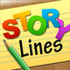](http://www.appolicious.com/games/apps/822996-storylines-root-one-inc)

StoThe idea behind the game is very simple. The first player must come up with a sentence or phrase, and write it down. The next player must then illustrate that phrase to the best of his or her ability. The third player will then try to describe what is happening in the picture without seeing the original phrase, and so on, until everyone has a chance to contribute. Drawing skill is not a prerequisite for this game, and in fact, the more difficult it is to decipher the drawings, the sillier the results become. **Free**.r

[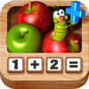](http://itunes.apple.com/us/app/adding-apples-hd/id464881662?mt=8&uo=2&partnerId=30&siteID=uIXydSSmUKA)[Adding Apples](http://click.linksynergy.com/fs-bin/stat?id=rm7r7jKp2P0&offerid=146261&type=3&subid=0&tmpid=1826&RD_PARM1=http%253A%252F%252Fitunes.apple.com%252Fus%252Fapp%252Fadding-apples%252Fid465950868%253Fmt%253D8%2526uo%253D4%2526partnerId%253D30) has a fairly simple interface – a wooden calculator with the numbers from 1-9, a chute that apples roll into, and a cheerful green worm to be your guide.  Your child is directed by the on-calculator worm to press any number button.  When she does, the corresponding number of apples rolls into the chute.  When another number is pressed (or the same number if you’re working on doubles) that quantity of apples – in another color – rolls into the chute. Free.

 **2x2=4**   
Advantages:  
-Two kinds of arithmetic operations: multiplication and division  
-A built-in multiplication table for learning  
-3 levels of the level of complexity(the speed of shooting at pirate is raising or lowering)  
-Two types for answer entering: by figures and by multiple choice  
-The history of already played games can be saved in order to trace the progress  
-The possibility to choose the range of the derived equations.

i

**Biology ExamHD**

This is an Educational Quiz for All Students ***  
300 questions to test BioSkills..  
Test your skill before your final exam.   
Description of the Game :  
** Each Correct answer carries 10 marks.  
** you get 3 lifes to find the correct answer.  
** Some of the questions are from Reproductory System of Human Beings.  
** If you give 3 wrong answer simultaneously then you will be out of the quiz.  
** If your marks is over 75 then you will be pass otherwise you will be failed.  
** Result will be declared after the exam.  
** you will notified with the correct answer after selecting the wrong answer..

**Websites:**

App Shopper: <http://appshopper.com/education/lets-name-things>

App Annie: <http://www.appannie.com/top/ipad/united-states/education/>

Physical Education: <http://thepeteacher.wordpress.com/2010/08/17/ipad-apps-for-physical-education/>