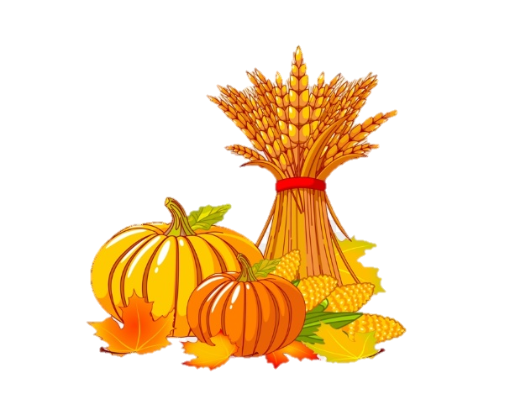

Weekly news from

Mrs. Newburn

**Upcoming Events / Reminders…**

* There will be NO SCHOOL on Wednesday, November 6th – the teachers will be in *another* training!
* If you’re interested…Sunday, November 10th is the benefit dinner for Mrs. Sloan at the school from 1-5.
* We are sending home the first 6 flashcards…please keep them and work on them nightly with your child. It is not mandatory for them to learn the letters in sign language – it’s just a nice skill to have ☺
* If you have not sent in headphones for technology, please do so ASAP.
* Thanksgiving break is from November 27th – December 2nd.



**Skills we are working on…**

* The letters “Aa, Tt, Ff, Ii & Ee”, their sounds and how to make them in sign language
* Writing names/recognizing letters in names
* Fine motor skills (writing, coloring, and cutting)

**Things to work on at home…**

**Things to work on at home…**

* Days of the week
* The more practice with fine motor skills, the better! Practice writing, coloring, and cutting!
* Help your child write the first letter of their name