Science Assignments:

Monday, April 20, 2020
Title: The Sun: Our Living Star PAGE# 13 (E.5.8A)
Directions: Click on the link to watch (and enjoy) the Pink Palace Sharpe Planetarium’s presentation about the sun (about 25 min). Read the following questions FIRST, before watching the presentation, so you will know what to listen and pay attention for. Then, answer the questions in your science notebook.
Choose ONE of these ways to answer the questions:
1. Write the questions and a short answer.
2. Write your answers in a complete sentence by restating the question.

Control + Click HERE for video.

Questions:
1. Why is our sun an important energy source for plants?
2. Name two ancient civilizations who considered the sun very important, even worshipping it.
3. Which two astronomers mentioned in this video contributed to the heliocentric theory?
4. Earth revolves around the sun, and the sun revolves around the center of the ___________________.
5. Our sun is an average size star called a yellow dwarf. About how many Earths could fit inside our sun?
6. What element is produced in the sun’s core by hydrogen atoms colliding?
7. What are the high energy particles given off by the sun called? (HINT: they create the beautiful northern and southern lights)
8. How does the energy we get from fossil fuels come from the sun?

**Control + Click this link to check out the other Pink Palace Museum To Go offerings the Pink Palace has made available to us during our school closure. There are movies like Wild Ocean and Mummies; Cool Science Activities Home like Growing and Shrinking Egg; and even some really interesting information about the Yellow Fever Epidemic that hit Memphis and our area in the late1800s.
************************************************************************************************
Tuesday, April 21, 2020
Title: The Planets PAGE #14 (E.5.8A)
Directions: Study Jams Powerpoints
Read through the powerpoint slides for the two presentations below. The powerpoint slides will automatically advance after about 15 seconds. You may also choose to use the yellow arrows on the right side of the slide to advance to the next one or go back to a previous slide. Record notes on page 14 of your science notebook. When you are finished, take the short quiz for each and write your results in your science notebook. Reread through any questions you missed to learn more.
Study Jams: The Inner Planets
Study Jams: The Outer Planets
************************************************************************************************
Wednesday, April 22, 2020
Today is the 50th Anniversary of Earth Day!
Control + Click here to see astronaut Jessica Meir’s message from the International Space Station (ISS).
Title: Earth Day PAGE #15
Directions: Earth Day for Kids Video and Questions
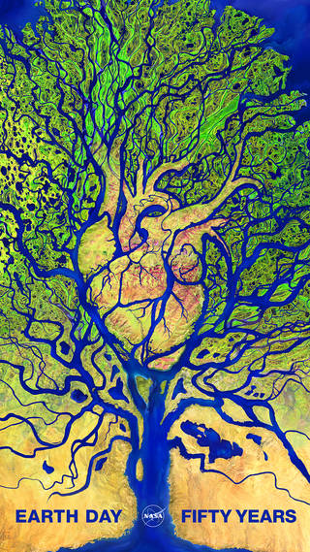
Click the link to watch the YouTube video about how Earth Day got started and how you can participate (about 5 minutes). Watch the video TWO TIMES. After the 2nd time, answer these questions on page 15 of your science notebook. You may want to pause the video to record your answers.
Choose ONE of these ways to answer the questions:
1. Write the questions and a short answer.
2. Write your answers in a complete sentence by restating the
question.

Click HERE for the video.

Questions:
1. What is Earth Day?
2. On what date does Earth Day fall each year?
3. Who first started Earth Day and where was he from?
4. How many people participated in the first Earth Day in 1970?
5. About how many countries now celebrate Earth Day?
6. Name at least 3 ways YOU can get involved.
************************************************************************************************
Thursday, April 23, 2020
Kahoot Challenges: Natural Resources and Reduce, Reuse, Recycle (E.5.10)
Complete the two Kahoot challenges. Use your first and last name as your nickname. You may complete the challenges more than once to improve your score. As always, your science notebook may be used as a resource.
Mrs. Matthews’s classes: Natural Resources: 0396673, 3Rs: 06438103
Mr. Allen’s classes: Natural Resources: 06007703, 3Rs: 04744123

************************************************************************************************
Friday, April 24, 2020 (E.5.10)
Student Choice!
Directions: Choose one (or more) of the following activities to complete. If you choose a Generation Genius video, you will complete the Exit Ticket as you have been doing in your science notebook. If you choose Study Jams, take the quiz and record your results in your science notebook, also, as you have been doing.
Title: Natural Disasters PAGE# 16
Generation Genius: Natural Disasters
Extreme Weather Solutions
Study Jams: Severe Storms slide show and quiz

