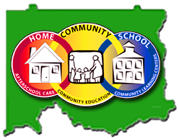
Elmore County Public Schools 21CCLC
Organizational Meeting
6 July 2012, 1-3 pm
Technology Conference Room

AGENDA:

Welcome

Introductions

Contracts, Summer Forms, Receipt Books, Brochures

Binders
- Program Updates
- Annual Reports
- Budgets and Finances
- Evaluations
- Family Workbook
- Federal Monitoring (Donna Goodwin)
- Grants and Reapplications
- Handbooks
- Management/Operation Forms
- Newsletters, Publicity and Communications
- Professional Development
- Schedules and Time Sheets
- Study Skills Booklet
- Summer Program
- Surveys

Site Directors’ Input

Dismissal

