Franklin County Upper Elementary
Summer Reading 2021
4TH Grade

Dear Families,
Summer break from school often means a break from reading. Research shows that students who never open a book during the summer often fall behind in reading. You can help your child avoid the “summer slide” by setting aside time each week for reading.
This summer FCUE students in grades four, five, and six are required to read two books from the attached reading list. Students must complete a book report using the attached form for the fiction book, and complete a biography project on a biography of their choice from the Who Was, Who Is, or I am biography collections or other biograph/autobiography title (instructions are attached). Students will turn in their book report and present their project on August 13th. Here are some tips to help:
- Books can be checked out at public libraries, or purchased using the following websites: www.amazon.com, www.barnesandnoble.com, www.booksamillion.com, and other similar websites.
- Your child will be required to test on his/her books by August 13th, and in order to ensure a good grade they may come to FCUE during the summer and test as soon as they finish reading so that they do not forget the book.
- Encourage your child to read! Listening to your child read out loud to you is a great way to spend time with them and let them know that you take their education seriously.
This summer reading project will be your child’s first grade in his/her reading class for the school year. It will be calculated as such:
Book report (fictional book- use attached form)
Presentation(nonfiction book- use directions attached)
AR book score(fiction book)
+ AR book score(nonfiction book)
Divide by 4 = test score
Please follow the attached guidelines and happy reading!!
Thank you,
FCUE Teachers

4th Grade Fiction Novels (Choose ONE)
(Make sure to choose a book you have not previously read and tested on. Renaissance will not allow you to retest on an AR book.)

Shiloh
By: Phyllis Reynolds Naylor
Book Level: 4.4
AR Points: 4.0
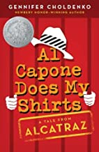

Al Capone Does My Shirts
By: Gennifer Choldenko
Book Level: 3.5
AR Points: 7.0
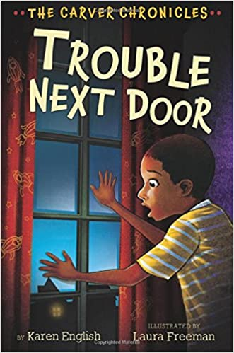

Trouble Next Door
By: Karen English
Book Level: 4.5
AR Points: 3.0

The Chocolate Touch
By: Patrick Skene Catling
Book Level: 4.7
AR Points: 2.0

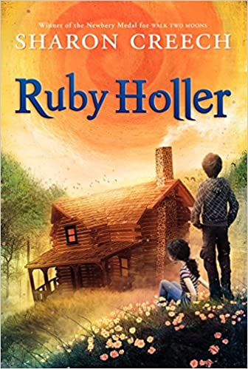
Ruby Holler
By: Sharon Creech
Book Level: 4.3
AR Points: 6.0

Fiction Book Report by:_________________________________Date:______________
Title: _______________________________________________________________________
Author:____________________________ Number of Pages:______________________
Genre:______________________________________________________________________
Setting: Where and when does your story take place?
Where:____________________________________ When:__________________________
Characters: Who are the characters in your story?
_____________________________________________________________________________
Plot: Describe the main events from your book in the Flow Map,
Beginnings:
Middle:

End:

Theme: What is the author’s main message in the story?
__________________________________________________________________________________________________________________________________________________________

New Vocabulary: Choose and define three new words from your book.
Word: | Page: | Definition:

Favorite Scene: Illustrate your favorite scene and add a caption.

__________________________________________________________________________________________________________________________________________________________
Text Connection: Make a Text-to-Text, Text-to-Self, or Text-to-World Connection.
(I thought it was interesting that …OR…remind me of…)

__________________________________________________________________________________________________

Rating: On a scale of 1(couldn’t stand it) to 10 (Loved it!), rate your book.

__________________________________________________________________________________________________

Recommendation: Would you recommend this book to a friend? Explain.

____________________________________________________________________________________________________________________________________________________________________________________________________

Points Possible: ____________________ Points earned:___________________________

Teacher Comments:
________________________________________________________________________________________________________________________________________________________________________________________________________________________________________________________________________
Biography/Autobiography Book Report Presentation
In the assignment, you will read a biography or autobiography, which is a factual story about a person’s life. You will then pretend to be this person in a dramatic presentation to the class. You are to dress up and use props. You may use note cards to assist you in your presentation.

*** Please keep in mind that “dressing up” as your person does NOT have to be expensive or elaborate! (Wearing a paper hat counts as dressing up!) Please do not spend a lot of money on this! Keep it simple! ***

To prepare this five- minute presentation, you will need to organize your notes to decide which facts will be the most interesting to share. Plan and organize your presentation so that you can portray your individual in an interesting way.

These are the facts that you MUST share:
- Name of the person
- Author of the book you read
- Date of birth and location of birth
- Family history
- Childhood
- What is your person known for? What is their greatest achievement?
- At least 2 unique facts about your person.
- Is your person still alive? What are they doing today? If not, when did your person die?

Practice your presentation, speak clearly and have fun!

4th Grade Non-Fiction Novels (Choose ONE)

ANY title (you haven’t already read) from Who Was? or Who is? Or I Am Series biography collection on a 3.5-4.9 Reading level or you may choose another biography.

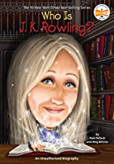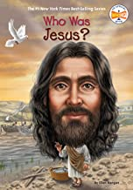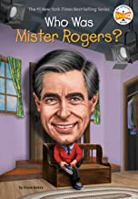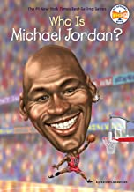

Examples of Biography Posters
(Use a story board or poster board for presentation)
We encourage you to dress the part of the person you read about!
