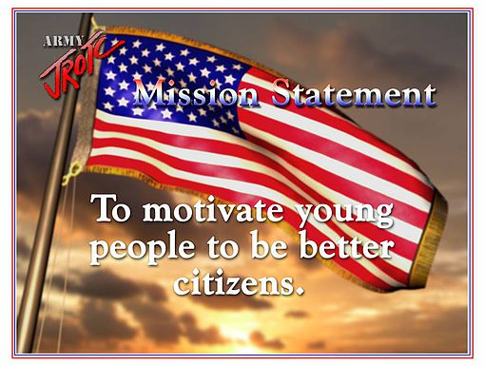

Motivating and developing young people is our primary mission and is what JROTC is all about. We are NOT military recruiters. We provide classroom instruction and extracurricular activities to help prepare Patriot Battalion JROTC Cadets for life after High School! Meanwhile, we want to ensure everyone--instructors, parents, and Cadets – have fun and enjoy this experience.

JROTC Overview Video
https://youtu.be/wZMOoh8JAWQ

