How to complete the online personal finance lessons:
-I am going to walk through the steps on Lesson 1.1 Taxes and Your Pay Stub. It can be found at the following link:
https://docs.google.com/document/d/17-QT9JpCJgID_cSmjunbwnXFsND63qZfJJyti7_PxaY/edit#

-Begin each step on the left side under Resources. I am starting with number 1 and then clicking on the blue text “Discussion Prompts”.
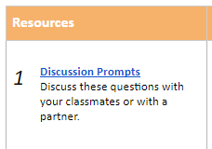This brings up a link I can follow to a short slideshow. The questions you can answer on your own or discuss with someone at home. The slides should look like this:
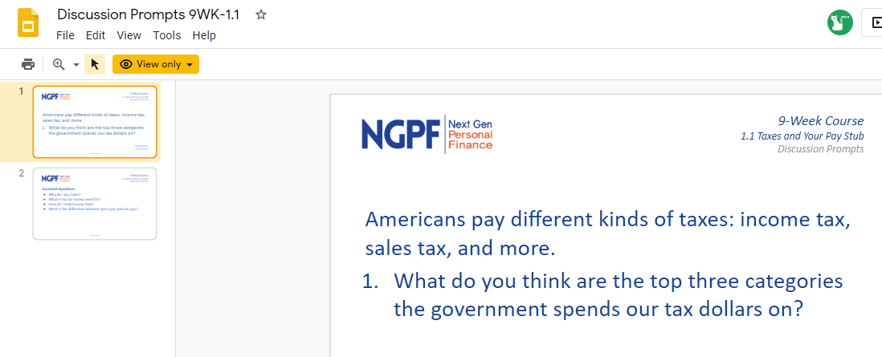

(Continued on next page……)

-I then close the slides page and go back to the original document to complete Section 2:
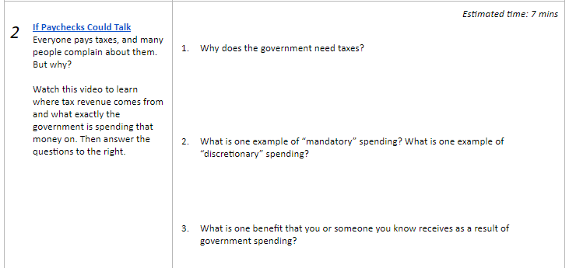

-Follow the same process as with part 1. Click on the blue text “If Paychecks Could Talk” and you should be taken here:
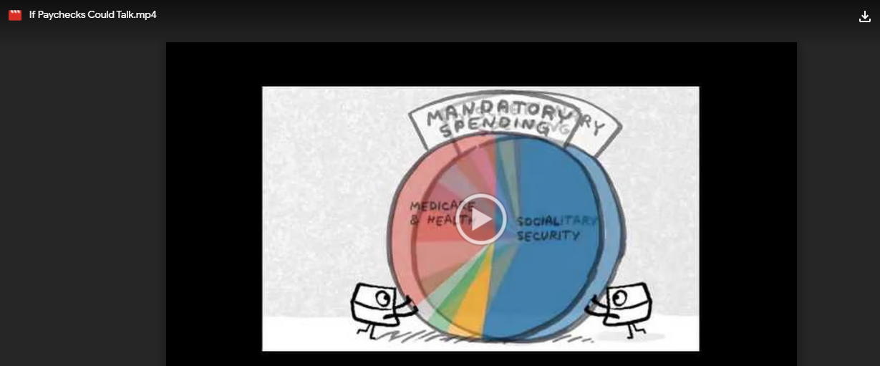
Once you watch the video answer the questions on the right again.

-Follow this process until you complete sections 1-6. The final section, number 7, is the exit ticket on each lesson. For this write 3 sentences about what you learned in the lesson.
That’s it! You can print and write on the lesson page to turn in later, write it on your own paper, or save it to your drive electronically. If you know how to share documents you can turn it in electronically as well. As always, let me know of any questions and how I can help!

