QUEST First Grade Weekly Work

Day 1 - March 16
Reading | Listen to this story- Pete the Cat: The Great Leprechaun Chase https://www.youtube.com/watch?v=aUiAnNXxvHc&t=190s  Why does Pete want to catch the leprechaun?  Listen to the story again and take the AR test. Here is the link to Ithica’s AR: https://hosted181.renlearn.com/49884/  And here is the quiz number for this book: 199661  It’s a 2.7 level book so be sure you listen to the book at least two times so you can get a good score!

Day 2 - March 17
STEM | STEM is so important and so fun! Today, try making this rainbow bridge with play-doh and pipe cleaners. Then, since it’s St. Patrick’s Day, use a small plastic/paper cup and some pennies and test how much weight your rainbow can hold.  Here’s one example:  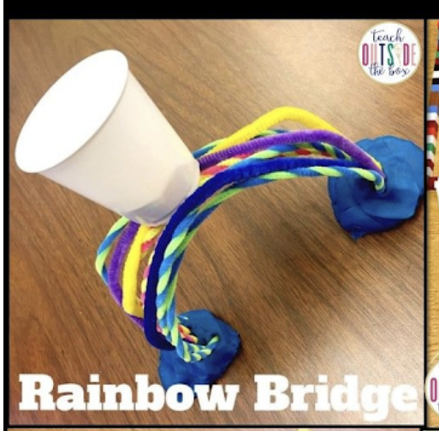  First, watch this video and talk about how bridges work: https://www.youtube.com/watch?v=oVOnRPefcno  Now“We are going to build a rainbow that is strong enough to hold the leprechaun’s pennies inside his pot of gold!”  Let’s build and test, counting the pennies as they are put in the pot of gold. Then answer these questions on a sheet of paper:  - How many pennies did your rainbow hold the first time you tested it?  - How many pennies did your rainbow hold the second time you tested it?  - What made your rainbow strong?  - What was hard about this STEM challenge?  I would love to see a pic of your rainbow bridge!  **If you don’t have the materials you need to make this STEM challenge, try using paper that you color to look like a rainbow and fold to make strong or even straws of some sort. **

Day 3 - March 18
Math | Visit this link to BrainpopJr.com to watch a video about 2D shapes: https://jr.brainpop.com/math/geometry/planeshapes/  If you need to log in, here’s that info:  Username: ithica  Password: brainpop  Then take the hard quiz and email me your score. (Ask mom or dad to help you with this.) Email me at teri.donaldson@carrollcountyschools.com  Practice putting shapes together using one of these games. Your pick!  https://www.abcya.com/games/shapes_geometry_game  https://www.turtlediary.com/game/compose-shapes-using-one-square-four-triangles.html

Day 4 - March 19
Math | Use this link to watch a NumbeRock video about 3D shapes: https://www.youtube.com/watch?v=ZnZYK83utu0  Then either write down 2 examples of real life things that are 3D shapes (2 examples of spheres, cones, cylinders, pyramids and cubes) on a sheet of paper.  OR, ask mom or dad to print this shape sort on your printer at home and you can cut and glue it correctly: https://www.cpalms.org/uploads/resources/34864/3D_Shape_Sort.pdf  **Parents, they only need to do ONE of the above activities after the video. Whichever is easier for you.**  Finally, play this 2D and 3D shape match game: https://www.abcya.com/games/shape_match

Day 5 - March 20
Science and Writing | Watch this Mystery Science (Mystery Doug!) video about dragons: https://mysteryscience.com/mini-lessons/dragons?code=cf7a9a0ab6fa36bc31be318b24221f4f#slide-id-5267  Write an adventure story in which YOU find a dragon! What does your dragon look like? Where do you find the dragon? What happens when it’s time for you to leave the dragon? (Draw a picture too to make your story more interesting!)  Finally, take a picture or scan it and email me your writing and picture. (Ask mom or dad to help you with this.) teri.donaldson@carrollcountyschools.com  If you would like to hear a story about a dragon in the Chinese New Year, watch this read aloud video: https://www.youtube.com/watch?v=XPmmSTfLuEI

