Sheet Music Scavenger Hunt
Name__________________________________
Write directly on your copy of the music:
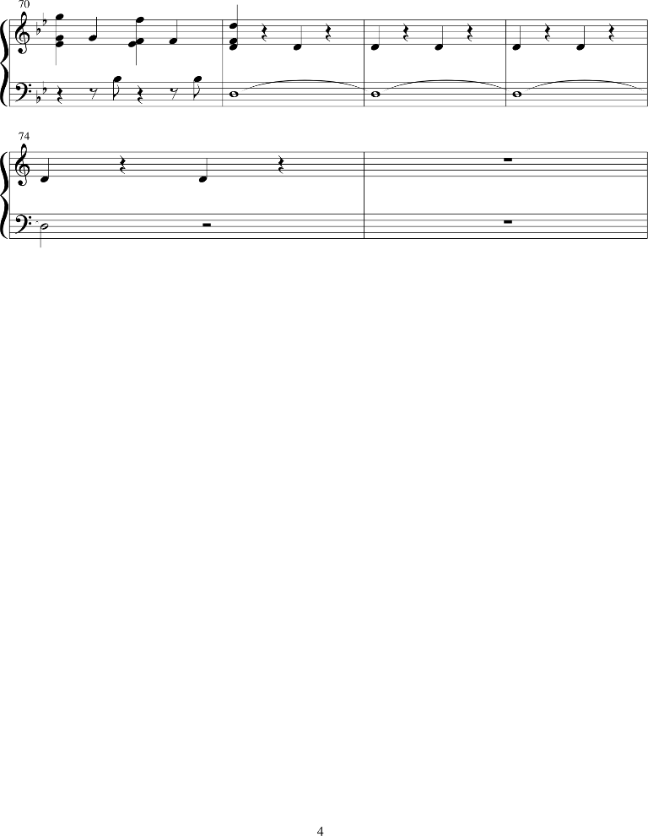
1. Circle measure 5.
2. Highlight all of the quarter rests.
3. Place an X over the dynamic symbol.
4. Write a W above the whole rests.
5. Write a T above the time signature.
6. Place a star over your first note.
Answer these questions here:
6. What is the letter name of the first note you play/sing? ___________
7. How many beats are there in each measure? ___________
8. How many measures are there on this page? __________
9. What is the tempo of this piece of music? _________
10. Who is the composer and/or arranger of this music? ________________________________
______________________________________________________________________________

CHALLENGE QUESTIONS (extra credit):
11. Name the Key Signature: ________
12. Who owns the copyright to this piece of music? __________________________________

