Strategy
Understanding How You Learn Best
People learn using three different learning modalities. A learning modality can be either visual (seeing), auditory (hearing) or kinesthetic (touching or moving). While you may use any one or all of these modalities at certain times, most of us use one modality more often than others. That modality is part of your preferred learning styles.
DIRECTIONS: To figure out your preferred learning style, pretend that you have to learn 20 new words and their meanings for a big test. How would you tackle this job? (Check any statements that describe you—you can have none or more than one in any category).
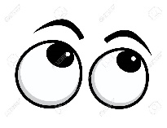 1. I would prefer to:
___________ read the words and definitions over and over again
___________close my eyes and “see” them in my mind.
___________look at pictures that portray the words and their meanings
If these are the ways you like to learn new material, you may learn best by seeing, and you are probably a visual learner.
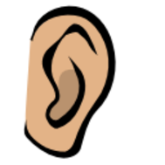
2. I would prefer to:
_________recite the words and definition to myself over and over
__________have the words and meanings taped and then listen to them.
_________discuss the meanings with someone
__________ listen to the teacher’s explanations and recall them later
If these are the ways you like to learn new information, you may learn best by
hearing, and you are probably an auditory learner.

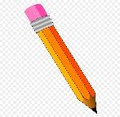 3. I would prefer to:
________write the words and definition
________draw pictures that remind me of the meaning
________move around as I concentrate
If these are the ways you like to learn new information, you may learn best
By feeling and moving, and you are probably a kinesthetic learner

4. Think of other examples which show whether you prefer an auditory, visual, or kinesthetic learning style and write them below.
___________________________________________________________________________________________
___________________________________________________________________________________________

If you checked off some preferences in each modality, it means that you use more than one modality to learn. Many people are like you and combine what they see with what they hear and write. Use your best learning style whenever you want to be at your most efficient for learning.

