HODGEN SCHOOL
SUPPLY LIST

Pre-Kindergarten
Pencil box
(3) 24 count box of crayons
2 glue sticks
1 package baby wipes
Small blanket
Backpack
Sleep mat

Kindergarten
Pencil box
(1) 24 count box of crayons
1 package of washable markers
1 Package pencils
1 Package glue sticks
2 large erasers
2 folders w/ inside pockets
3-inch, 3 ring binder
Backpack
Sleep mat
Optional-small blanket or pillow for rest time

1st grade
Pencil box
(2) 24 count box of crayons
24 plain pencils
1 pack of colored pencils
2 packages of markers
2 large erasers
4 glue sticks
Blunt tip scissors
Backpack
3 boxes of Kleenex

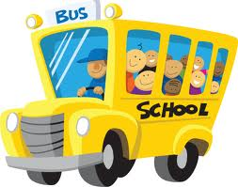

2020-2021
School Year

2nd grade
Pencil box
(24) No. 2 plain pencils
(2) 24 count box of crayons
Washable markers
2 Large erasers
Scissors
4 Glue sticks
2 pocket folders
1 wide ruled notebook
2 boxes of Kleenex

3rd grade
24 plain pencils
2 large erasers
(2) 24 count box of crayons
2 packs of colored pencils
4 glue sticks
2 pocket folders
Pencil sharpener
2 yellow highlighters
2-inch, 3 ring binder

4th grade
Pencil box
Wide ruled notebooks
No. 2 plain pencils
Package of erasers
2 pocket folders

5th-8th grades
No. 2 pencils
Notebooks
Erasers

