PAPER PLANE CORN HOLE

Get Ready: You’ll need 3 paper sheets per player, a bucket or laundry basket.

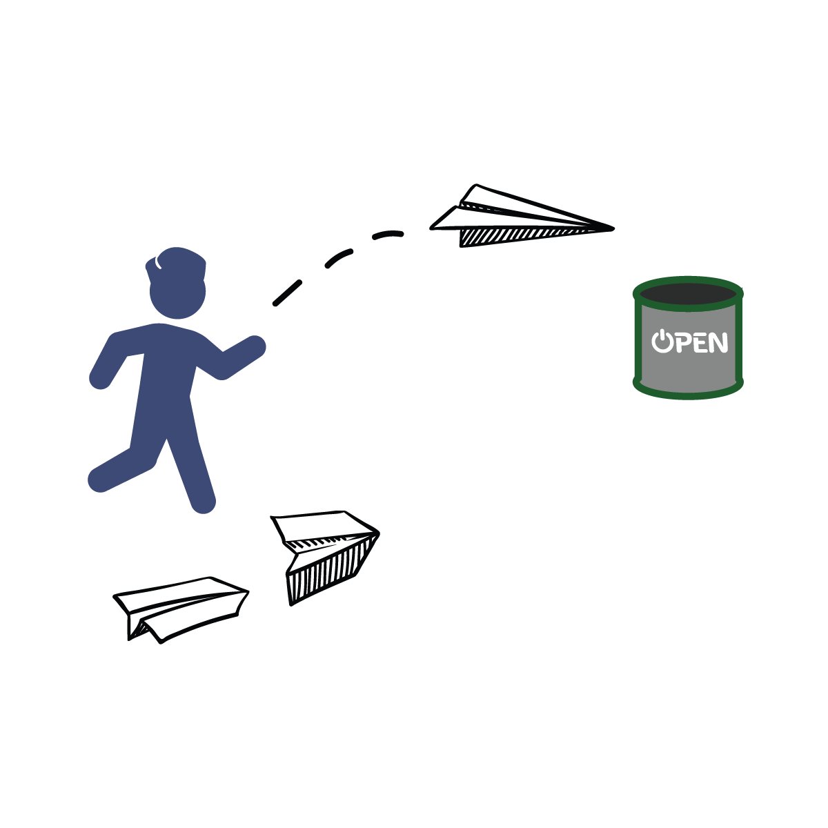
Get Set: Create 3 paper airplanes using a design of your choice. Place your bucket 5-10 feet away from your throwing line.

GO!
- This event is called Paper Plane Corn Hole.
- The object of the game is to score points by throwing your paper airplane into your bucket. You have 1 minute to score as many as possible.
- Design and create 3 paper airplanes.
- On the start signal, fly your airplanes as many times as you can toward your bucket.
- Score 1 point for every plane that hits the outside of the bucket and 2 points for every plane that lands in the bucket.
- Write your score down on the official Field Day Score Card.

WIND BOWLING

Get Ready: 1 Balloon (or Paper Plate), 10 Plastic Cups

Get Set: Set 10 empty plastic cups at the edge of a table in single file along the edge.
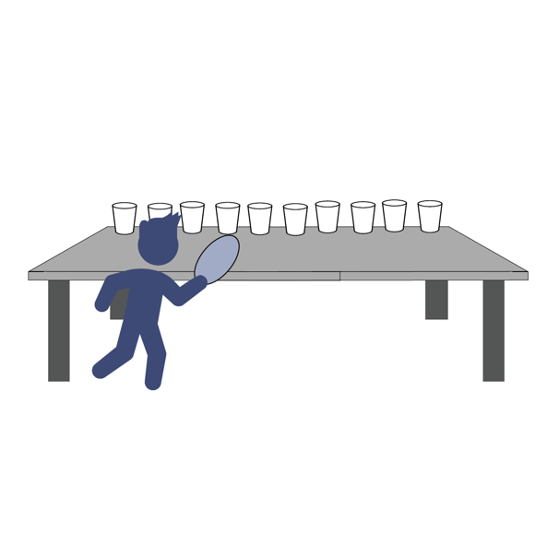
GO!
- This event is called Wind Bowling. The object of the game is to knock all the cups off a table edge using only the air from the balloon or paper-plate fan.
- You’ll do that by blowing the balloon up and aiming the escaping air towards the empty plastic cups. If you don’t have a balloon you can wave the paper plate like a fan with the fan’s air hitting the cups.
- Score a point for every cup that gets knocked off the table.
- You have 1 minute to knock down as many cups as you can.
- Write your score down on the official Field Day Score Card.

SOCK-ER SKEE-BALL

Get Ready: 10 sock balls, 1 Laundry Basket, 1 Bucket, 1 Tupperware container

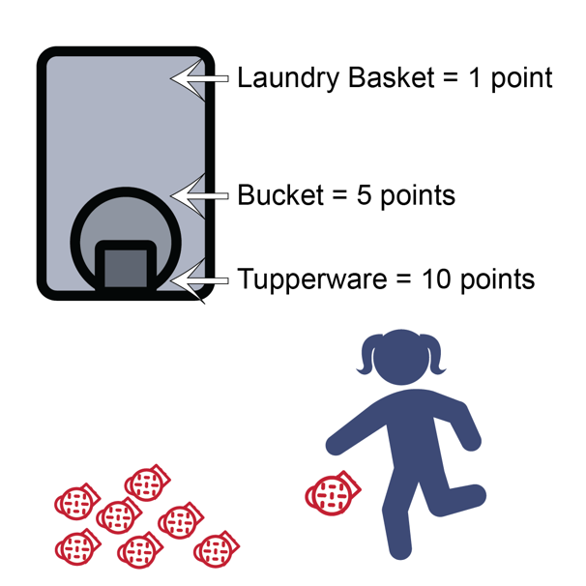
Get Set: Roll up the socks to make sock-balls. Stack the targets into skee-ball formation with the Tupperware inside the bucket and the bucket inside the laundry basket.

GO!
- This event is called Sock-er Skee-ball. The object of this game is to score points by kicking the sock ball into the skee-ball targets.
- You’ll do that by using your feet to kick the sock ball into the target.
- Score 1 point for every sock ball that lands in the laundry basket.
- Score 5 points for sock balls in the bucket.
- Score 10 points for sock balls in the Tupperware container.
- You get 10 chances to score as many points as you can.
- Write your score down on the official Field Day Score Card.
TOWEL FLIP CHALLENGE

Get Ready: 1 large beach or bath towel

Get Set: Lay your towel out flat on your floor and stand on it.

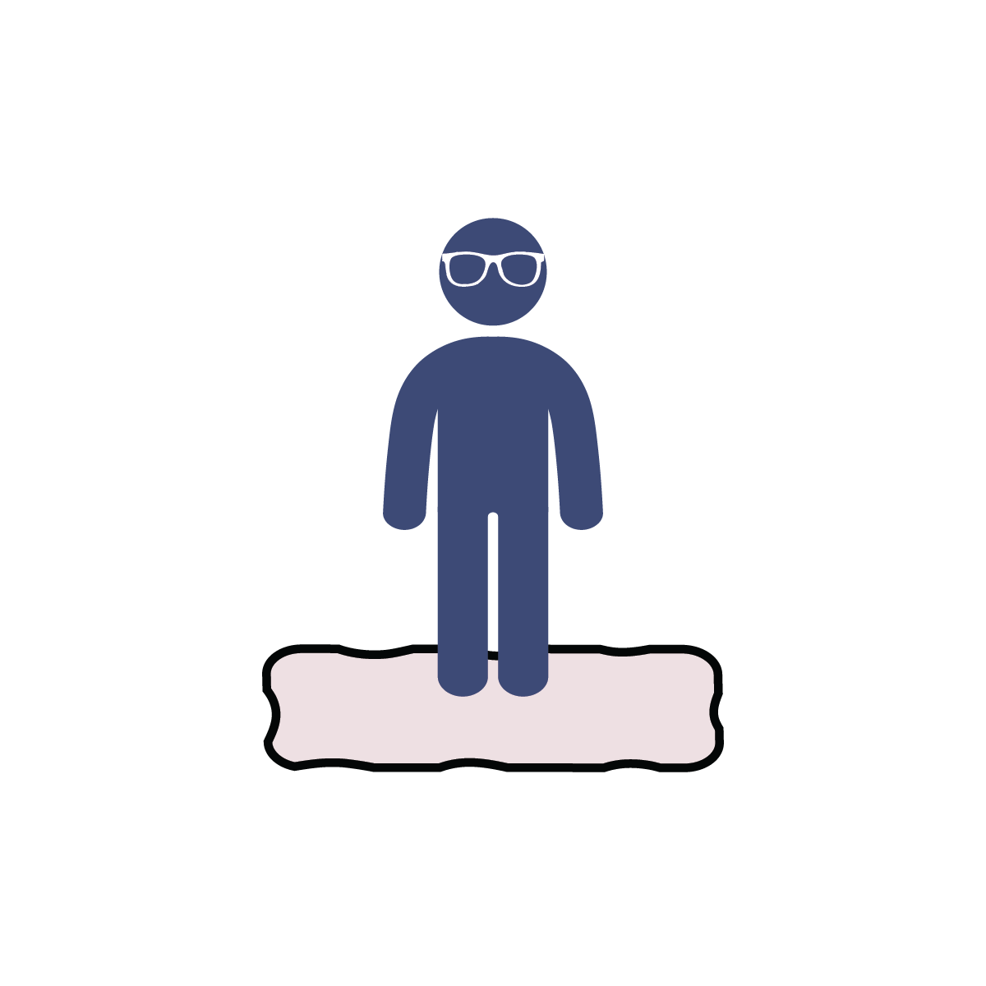
GO!
- This event is the Towel Flip Challenge. The object of this game is to flip the towel as fast as you can without stepping off of it.
- You can take small steps from one part of the towel to another. However, you can only move it when you have both feet firmly in place on top of the towel.
- The towel must be flat at the start and flat at the finish.
- You have 1 minute to complete the challenge.

MILK JUG RELAY

Get Ready: Two 1-Gallon Milk Jugs, Items to Mark Start/End Points (cones, socks, plastic cups, etc.), Clock or Stopwatch

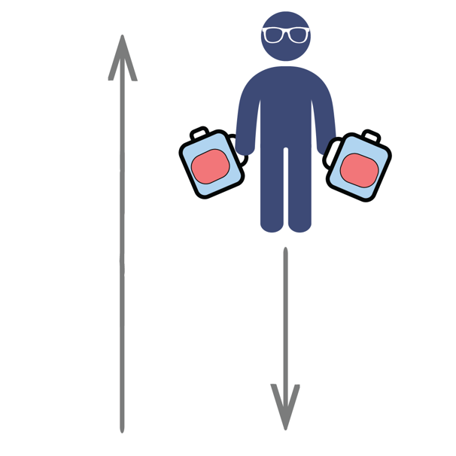
Get Set: Set up an area to move in by making a starting point and ending point. Distance can be 15 to 30 walking steps from beginning to end. Fill two used 1-gallon milk jugs with water (¼, ½, or full) and place at a start spot.

GO!
- This event is called the Milk Jug Relay. The object of this game is to carry the milk jug across the room as many times as you can.
- You get 1 point for each full length you travel.
- Add extra challenge by carrying two milk jugs at once.
- You have 1 minute to complete the challenge.
- Write your score down on the official Field Day Score Card.

