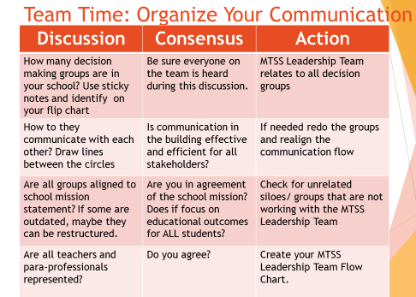
Communication Flowchart
- Must be planned – does not happen in a rush or spontaneously
- Systematically assures that everyone is in the loop
- Supports staff buy-in
- Supports implementation
- Supports staff development
- They look different for every building

Examples of Communication Flowcharts:

