**Listening & Feelings**

**CARED FOR**

**ANGRY**

**HAPPY**

**AFRAID**

**CONTENT**

**HEARD**

**SPECIAL**

**IGNORED**

**SAD**

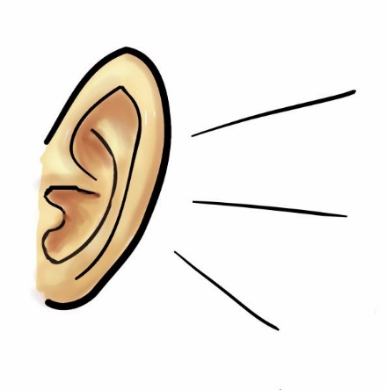

**IMPORTANT**

**PLEASED**

**ASHAMED**

**SATISFIED**

**CONFUSED**

**DISGUSTED**

**GLAD**

**GRUMPY**

**HURT**

**SILLY**

**HAPPY**

**OPEN**

**PLEASANT**