SSWH1 Standard Notes Questions:
- What were the 4 river valley civilizations?

- What does Mesopotamia mean? Which rivers make up Mesopotamia?

- What began popping up in Mesopotamia? Example?

- What is specialization of labor? Example?

- How were Mesopotamian gods viewed?

- What are ziggurats? How were ziggurats used?

- What is a city-state?

- What is cuneiform? What does cuneiform mean? How was cuneiform used?

- Who developed the first empire? What is an empire? (not on slide)

- What is the Code of Hammurabi? Significances?

- Why did villages grow up around the Nile River Valley?

- What is the “gift of the Nile”?

- What is a pharaoh? How were pyramids used?

- How do historians divide early Egyptian history?

- What does polytheistic mean? Who dominated Egyptian society?

- What is the Divine Right of Kings? How does the DRK relate to pharaohs?

- What are hieroglyphics?

- How were Mesopotamian and Egyptian society similar?
Mesopotamian and Egyptian Societies
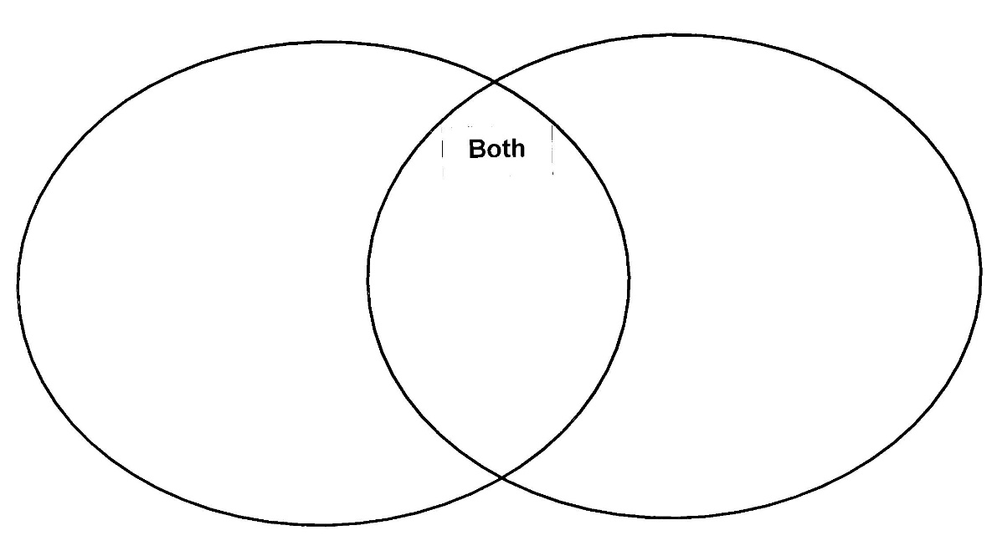
- Which two urban center dominated the Indus Valley Civilization?

- What features and items were found in these cities within the IVC?

- What did urban areas both benefit from and suffer from along the Yangtze and Yellow Rivers?

- What is the first documented dynasty in China?

- What is Zoroastrianism? Where was this religion developed? Significances?

- What was cultivated by early American societies? Name of dominate culture?

- Provide the significant aspect of Olmec society.

- What advancements did early West African society experience?

- What is the Bantu Migration? Results?

- Under which group did monotheism reach its most enduring from?

- What is monotheism? What are the basic aspect of Judaism?

