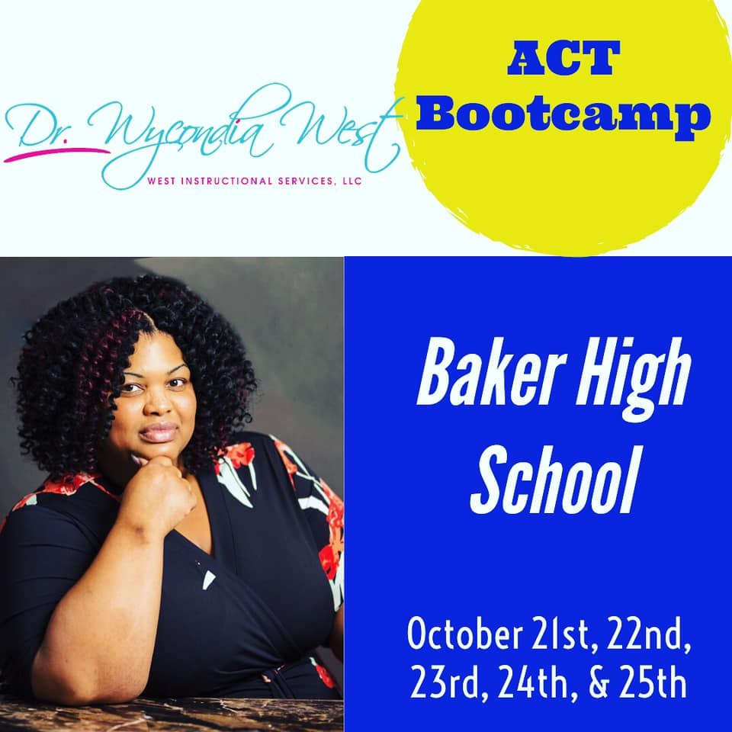

Teachers please announce and post in your classroom.

**11th Grade students ONLY**

**March 2 – 6th &**

**March 9th**

**5:30 – 7:00 pm**

**\**for Baker 11th grade students only\** only**

$75.00

**Register and pay for the course on mcpss.com:**

* Click on the blue megaphone entitled: **“Get Information”** then click on **“E-Funds Fee Pay”**
* Select **“Pay for BHS ACT Prep/Bootcamp”** then **“Create an account”** with **student’s name** and **add cost of course to your cart (75.00).**
* You may pay with an e-check **(no fee)** or a credit/debit card **(will charge a convenience fee)**
* Print a copy of your registration and present at the first class as verification of payment
* Please email all questions/concerns to [kmatthews2@mcpss.com](mailto:kmatthews2@mcpss.com)