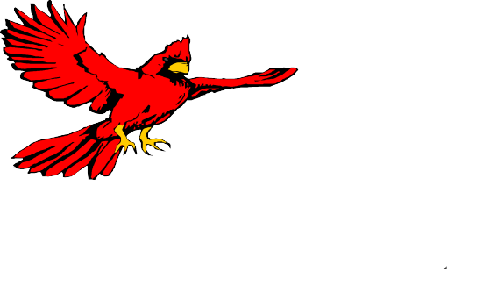
Nora Mae Hutchens
Elementary School Second Grade Supply List
$ 5.00- School Fee for Computer Supplies, First Aid and Mailings
$5.00
Students are required to have these supplies on hand DAILY

Quantity | Item
1 | Pair of Fiskars 5" scissors (blunt end)
4 | 24 count Crayola Crayons
12 | Elmer's Glue sticks
4 | Elmer's White School Glue
24 | Ticonderoga Pencils
1 | Crayola Classic Washable Markers 8 count
2 | 1 inch White Binders with Clear View Sleeve on Front
2 | Mead Composition Wide Ruled Notebooks
1 | Pack of 8 count Crayola Watercolors
1 | Clear Front Zipper Pouch (for 3 rinq binder)
1 | 8 count Avery two pocket plastic dividers (for 3 ring binder)
2 | Wide Ruled Spiral Notebooks
1 | Small Plastic School Box
2 | Plastic Folders with Brads and Pockets
1 | Package of Black Dry Erase Markers - 4 count
2 | Chubby Pink Erasers
1 | Package of Wide Ruled Loose Leaf Paper

PLEASE DO NOT PUT NAMES ON ANY OF THE ABOVE LISTED ITEMS

NO ROLLING BOOKBAGS/BACKPACKS

Please label all coats, sweaters, lunchboxes, etc.
Some items will need to be replenished during the school year!

