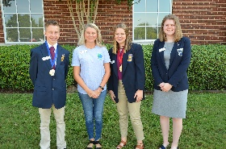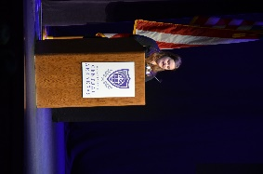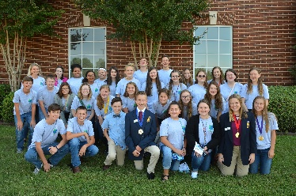10 **Reasons Why Should Join FBLA**

**PJH**

**20-21**

1. *It looks great on a resume!!*
2. *Fall and Spring Conference*
3. *State competition in Little Rock, AR . . . fun!*
4. *Networking with others.*
5. *Best dressed organization on campus!*
6. *Develop interpersonal skills—opportunities to compete at District Competition (online tests, projects, and presentations).*
7. *Fun social activities*
8. *Lifelong friendships. Virtual or in-person we will make it work!*
9. *Great experiences!*
10. *Opportunities for travel around Arkansas and the USA!*

You

