- Create a Characteristics of Life concept map and add examples with pictures (using ipad/computer or Nat Geo magazines)
- You can use the book or resource info on the next pages or the iPad/computer to review each characteristic
- Follow up Question: Assume that you found an object that looks like a dead twig. You wonder if it might be a stick insect. How could you determine if it is a living thing?

Sample Concept Map (can draw on Microsoft Word or the popplet app):
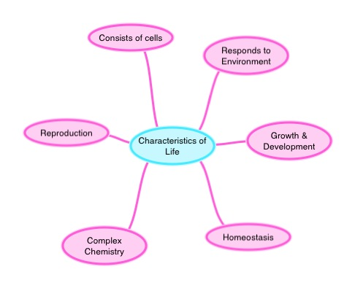

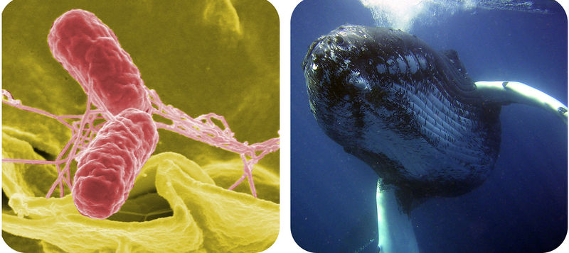
What do a bacterium and a whale have in common?
Do they share characteristics with us? All living organisms, from the smallest bacterium to the largest whale, share certain characteristics of life. Without these characteristics, there is no life.

Characteristics of Life
Look at the duck decoy. It looks very similar to a real duck. Of course, real ducks are living things. What about the decoy duck? It looks like a duck, but it is actually made of wood. The decoy duck doesn’t have all the characteristics of a living thing. What characteristics set the real ducks apart from the decoy duck? What are the characteristics of living things?
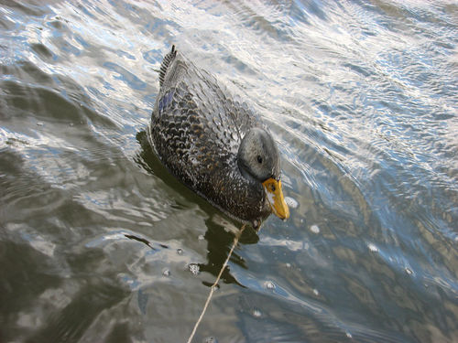
This duck decoy looks like it’s alive. It even fools real ducks. Why isn’t it a living thing?

To be classified as a living thing, an object must have all six of the following characteristics:
- It responds to the environment.
- It grows and develops.
- It produces offspring.
- It maintains homeostasis.
- It has complex chemistry.
- It consists of cells.

Response to the Environment
All living things detect changes in their environment and respond to them. What happens if you step on a rock? Nothing; the rock doesn’t respond because it isn’t alive. But what if you think you are stepping on a rock and actually step on a turtle shell? The turtle is likely to respond by moving—it may even snap at you!

Growth and Development
All living things grow and develop. For example, a plant seed may look like a lifeless pebble, but under the right conditions it will grow and develop into a plant. Animals also grow and develop. Look at the animals in Figure below . How will the tadpoles change as they grow and develop into adult frogs?
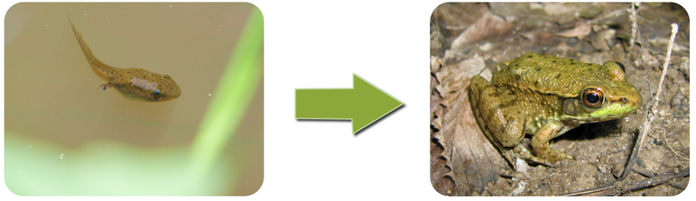
Tadpoles go through many changes to become adult frogs.

Reproduction
All living things are capable of reproduction. Reproduction is the process by which living things give rise to offspring. Reproducing may be as simple as a single cell dividing to form two daughter cells. Generally, however, it is much more complicated. Nonetheless, whether a living thing is a huge whale or a microscopic bacterium, it is capable of reproduction.

Keeping Things Constant
All living things are able to maintain a more-or-less constant internal environment. They keep things relatively stable on the inside regardless of the conditions around them. The process of maintaining a stable internal environment is called homeostasis . Human beings, for example, maintain a stable internal body temperature. If you go outside when the air temperature is below freezing, your body doesn’t freeze. Instead, by shivering and other means, it maintains a stable internal temperature.

Complex Chemistry
All living things—even the simplest life forms—have complex chemistry. Living things consist of large, complex molecules, and they also undergo many complicated chemical changes to stay alive. Complex chemistry is needed to carry out all the functions of life.

Cells
All forms of life are built of at least one cell. A cell is the basic unit of the structure and function of living things. Living things may appear very different from one another on the outside, but their cells are very similar. Compare the human cells on the left in Figure below and onion cells on the right in Figure below . How are they similar? If you click on the animation titled Inside a Cell at the link below, you can look inside a cell and see its internal structures. http://bio-alive.com/animations/cell-biology.htm
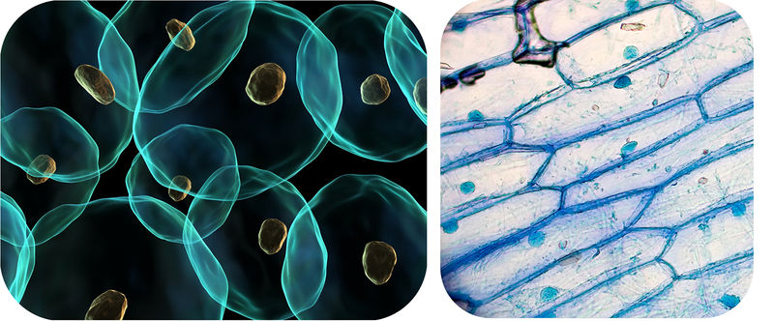
Human Cells (left). Onion Cells (right). If you looked at cells under a microscope, this is what you might see.

Summary
- All living things detect changes in their environment and respond to them.
- All living things grow and develop.
- All living things are capable of reproduction, the process by which living things give rise to offspring.
- All living things are able to maintain a constant internal environment through homeostasis.
- All living things have complex chemistry.
- All forms of life are built of cells. A cell is the basic unit of the structure and function of living things.
- See more at: http://www.ck12.org/biology/Characteristics-of-Life/lesson/Characteristics-of-Life/#sthash.c8jIxDGg.dpuf

Source: http://www.ck12.org/biology/Characteristics-of-Life/lesson/Characteristics-of-Life/

