**Grading Policy**

1. Major tests and quizzes will be announced in advance. Point value will vary according to material.
2. The art student is responsible for all class notes given. Notes will be kept in the sketchbook along with the weekly sketchbook assignments.
3. Students who are absent are responsible for missed class assignments.
4. All class assignments are due on the day of the critique. Critique days will be announced ahead of time.
5. Any student with an excused absence will be allowed extra time to complete the art assignment, however this will be done before or after school.
6. Late Projects : 10 points will be deducted from the final project grade for every day late. After day 3 the project will be a zero.
7. Grades for this course will be determined as follows:

65% Projects/ Critiques

30% Daily Work

5% Art History

Supplies are due by August 25th. Please talk to me if you have any questions or concerns.

**ALL** students are required to bring **ALL** materials with them to class. The portfolio and paper towels will stay in the art classroom. It is impossible to create any art assignment without the necessary supplies. Failure to bring supplies will result in disciplinary actions.

**Required art supplies**

**Art fee $5.00 is due by September 2nd**

**Wooden Pencils (needed for every class)**

**colored pencils (basic set of 12 or more)**

**Black Sharpies (4 fine & 4 ultra fine)**

**1 sheet of 28x22 poster board (to create a portfolio)**

**1 Roll of paper towels**

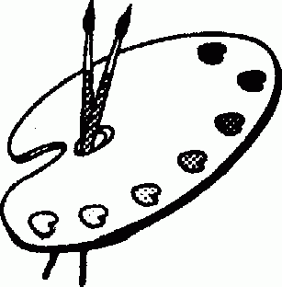

**Art Classroom Rules and Expectations**

1. ALWAYS be in your seat when the tardy bell stops ringing.
2. ALWAYS work quietly within the classroom.
3. ALWAYS clean up after yourself and be responsible for your work area.
4. ALWAYS come prepared for class.
5. ALWAYS put materials back in the proper place.
6. ALWAYS work only on art assignments and use your time wisely.
7. ALWAYS be respectful to others and their artwork.
8. ALWAYS be respectful of our school.

Art Survey -The high school Arts Survey course is an optional academic, multidisciplinary approach to the study of the arts. Arts Survey comprehensively introduces students to the four arts disciplines—dance, music, theatre, and visual arts—and helps them develop an awareness of the contributions artists have made to society across the years. High school students completing the Arts Survey course may earn the one-half arts education credit required for graduation

**PHS Art I Syllabus**

Mrs. Helgeson – ART ROOM II Christiana.helgeson@acboe.net