2021-2022
Calhoun R-VIII
School Transportation Handbook

Shane Stocks, Superintendent

Home of the Eagles

Dear Bus Drivers,

Calhoun R-VIII School District believes the safe and efficient transportation of students is a core function of the district. The district operates a small fleet of buses. At any time bus drivers may be confronted with unexpected conditions relating to weather, mechanical problems, accidents, or other circumstances beyond their control. The information in this section will serve as a guide for bus drivers in handling unforeseen problems that may arise. All bus drivers should be familiar with the "School Dismissal Procedure" outlined in this handbook. Drivers are expected to understand the emergency provisions contained in this section. It shall be the duty of the Transportation Director to ensure a printed copy of this handbook is available in all student transportation vehicles. A proper response to emergency situations is a further extension of the driver's responsibility to provide for the safety of bus passengers entrusted to his/her care.

Shane Stocks, Superintendent
Mission Statement
The Calhoun R-VIII School District is preparing motivated, responsible, productive,
lifelong learners.

BOARD OF EDUCATION

The Board of Education is a representative body elected by the registered voters of the district. It is the purpose and the role of the Board to exercise general supervision over the school and to ensure that it is maintained as provided by the state statutes, the rules and procedures of the Missouri State Board of Education and/or the Missouri Department of Elementary and Secondary Education, and the policies, rules, and procedures of the district. In addition, the Board is accountable to the electorate, and shall be responsive to the educational needs and the imposed financial constraints of the district. School Board Policies may be found at www.calhoun.k12.mo.us and in the Superintendent’s Office.

CHAIN OF COMMAND
Transportation staff are expected to follow the chain of command for all communication and grievance purposes. The chain is as follows: You→ Superintendent → Board of Education.

Emergency Telephone Numbers
- Fire 911
- Henry County Sheriff 1-660-885-7021
- MO Regional Poison Information 1-800-366-8888
- MO State Highway Patrol 1-800-525-5555
- Weather & Road Conditions (statewide) 1-800-222-6400
- Shane Stocks, Superintendent 1-660-694-3422 School#

2021 - 2022
District Calendar
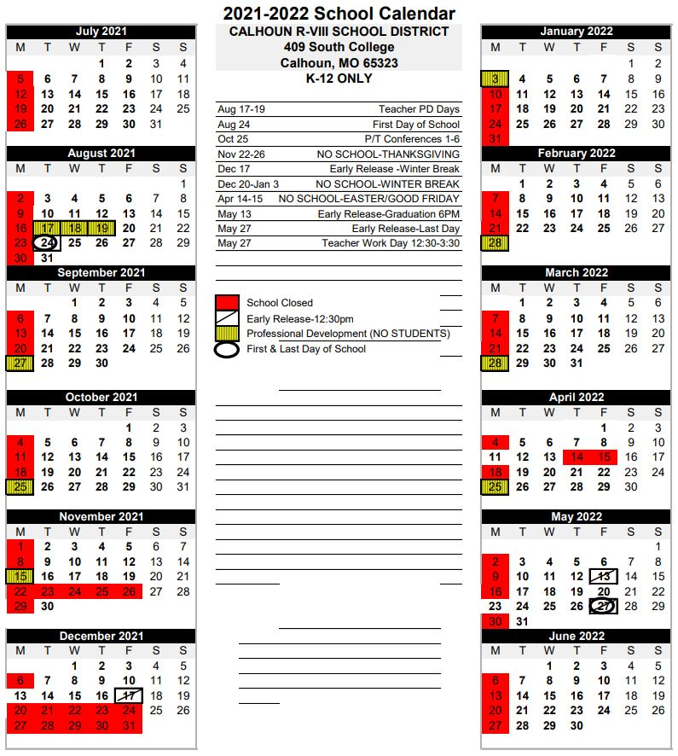

BELL SCHEDULE

1st Hour | 7:45 - 8:42
2nd Hour | 8:45 - 9:42
3rd Hour | 9:45 - 10:42
4th Hour | 10:45 - 11:42
Lunch: K - 6th | 10:55 - 11:15
Lunch: 9th - 12th | 11:42 - 12:02
5th Hour | 12:06 - 1:03
6th Hour | 1:06 - 2:03
7th Hour | 2:06 - 3:03
8th Hour (Intervention) | 3:06 - 3:30

Accident Procedures

No two accidents are the same. The sequence here may not be the same for every accident. The driver’s primary responsibility is to the pupil passengers. Therefore, it is the driver’s responsibility to remain calm. If the driver is unable to physically perform his/her duties, he/she should direct others to do them. Should this be the case, the oldest and most capable passenger(s) should be asked to help. The following procedures are to be followed in the unlikely event an accident occurs:

- Turn off the ignition switch
- Set the parking brake
- Remain calm and reassure passengers
- Protect the passengers and the vehicle from further accidents and injuries
- Check for any injuries to passengers
- If passengers are hurt, follow first-aid procedures and summon assistance
- Be alert regarding fire, or the possibility of fire
- Look for smoke
- Check for ruptured fuel tank and lines
- Check for electrical fire
- Check for a hot tire which may catch fire
- Use warning devices such as reflectors where applicable
- Keep all passengers in the vehicle unless conditions warrant evacuation (fire, hazardous material spill or another danger)
- Account for all passengers both presence and injury status.

Under normal circumstances, the vehicle(s) involved should not be moved until law enforcement personnel tell the driver to do so. When police, fire or emergency personnel arrive, they are in
command of the scene; the driver does not maintain control over the scene of the accident. The driver should focus control over the pupil passengers. Do not discuss the facts of the accident except to give information to police, fire and rescue personnel, and to transportation officials.

Provide information about the school bus, insurance, owner and driver data to local officials if requested. An emergency packet should be carried on the school bus and should include the registration information, emergency phone numbers, and any additional directories covering this subject. Be sure to obtain the names, addresses, and license numbers of any witnesses. Always follow any other directives issued by state or local school districts in the event of an accident.

One of the big dangers when involved in an accident is to allow the passengers to get out of the school bus and mill around the scene or on the roadway. If the bus must be evacuated because of fire danger or other reasons, be sure the passengers are moved to a safe location off the roadway and kept under control until given further instructions from an Officer or School Administrator.

Emergencies

The safety of the bus and equipment is secondary to the safety of the students. No attempt should be made to save equipment or personal items until all students are off the bus, safely out of danger, and supervised.

In the event of a major emergency (fire, flood, earthquake, collision with another vehicle or at a railroad crossing), the school bus driver’s first responsibility is the safety and welfare of the students. The bus driver will follow the emergency guidelines listed below, to the best of his/her ability. Passengers on the bus, both students and adults, will act under the driver’s instructions.

- Bring the bus to a stop in the safest possible location and set the parking brake
- Turn ignition to accessory and activate the hazard lights
- Notify School
- Remain calm and reassure the students

Next survey the scene, evaluate the circumstances, and determine if it is it safer to continue driving the bus, or to remain where the bus is parked, and if student evacuation is necessary. Recognize the hazard, give the order to evacuate, and evacuate using all available exits.
Remember, in most cases, it is generally safer to remain on the bus.

If you determine it is safe to continue, continue on route. If you decide not to continue driving and not to evacuate then stay with the passengers, notify school, and monitor communication.

If it is decided evacuation is required, then notify the school immediately, remove the ignition key and determine which emergency exit(s) will be used. Upon exiting the bus, direct/assist ambulatory students from the exit(s) to a safe regrouping area at least 100 feet from the bus and up wind from any fire, if possible. Make sure to send the first aid kit with the group.

If a paraprofessional is aboard the bus during evacuation, have him/her assist by releasing tie-downs or other securement for all passengers. Have the paraprofessional move the wheelchairs/car seats/students to the proper emergency exit. If alone, release the tie downs and/or other securement and move the wheelchairs/car seats/students to the appropriate emergency exit. If the wheelchair lift is not operable, remove the students from their
wheelchairs/car seats and carry them off the bus to the dispersal (regrouping) area. Place the wheel chairs/car seats by the appropriate emergency exit. If the student is in a wheelchair, exercise caution as some pupils have catheters or feeding tubes. The tubes/hoses are sometimes anchored to the wheelchair. If straps are severed and the pupil is pulled from the wheelchair to evacuate, any bodily (including internal) hookups are likely to be ripped from the body and possibly cause severe internal problems. Get assistance from the paraprofessional, or a passerby if available.

Retain the passengers in the dispersal area, or safer area if available. If the group is moved, notify office. Remain in the dispersal area until the emergency is over and it is either safe to return to the original bus or you receive additional guidance from emergency crews, the transportation director, or the superintendent is given.

In case of fire on the school bus, remember fire normally moves up and out. Crawl low in smoke and heat. Within two minutes the smoke becomes too toxic to breath. All students should be physically removed from their wheelchairs, car seats, bench seats, and carried to the exit.

After the emergency has passed, obtain or write down the following passenger information:

- Names
- Addresses
- Telephone Numbers
- Injuries
- Route Information
- Names of emergency transportation, if required
- Where students were transported to, or to whom they were released

Remember that during times of crisis situations can become very hectic. However, all the policies concerning student transportation are still in effect. Release students only to parents/guardians, school staff, a site manager, a district official, a mass care coordinator, the National Guard, a representative of the American Red Cross, police, sheriff, or the fire department. Notify the Superintendent when all children have been properly released and report the location. In all cases, follow the directions as given by the district, local authorities, and the Office of Disaster Preparedness.

Emergency Drills

Emergency drills are set up through the school office and are to be conducted on campus only. At least one evacuation drill per semester will be planned using the emergency rear door.
The purpose of such a drill is to make students conscious of the emergency exit, should it be needed. Care should be taken to see that the unloading drill does not constitute a hazard.

In emergency situations or drills, a responsible older student, with parental consent, seated near the back of the bus should be instructed to exit the emergency door first. This student will then direct all students to a central point that can be reached safely off the roadway. Students should remain as a group in the designated area until the emergency or drill is over or they are further instructed by law enforcement or school officials.

Intruders

Unauthorized individuals are not allowed on the school bus. Should an unauthorized individual attempt to board the bus the driver will take the following steps:

- Ask the individual to step off of the bus and inform them that trespassing on a school bus is a violation of both Missouri Law and School Board Policy.
- If a person refuses to leave the bus, the driver will make a call requesting the Transportation Director or School Administrator to come on site
- If deemed necessary, law enforcement may be contacted

Evacuation Procedures for Student Trips and Activities

In order to ensure the safety of school bus passengers in an actual emergency, every school bus driver assigned to transport students on activity trips or field trips should assign an evacuation team prior to each trip. The team may consist of teachers, coaches, students or any other passengers. Remember some students who usually walk to school, may at times, ride a school bus on field and activity trips, and should receive readership training. Passengers assigned to evacuation teams must be seated where they can effectively carry out their responsibilities in an emergency. Each evaluation team should consist of at least the following:

- A passenger assigned to set the parking brake, turn off the engine, turn on the hazard lights and call in on the radio by or other means, to report the incident to the transportation department, should the driver be unable to do so.
- A passenger assigned to take the first aid kit off the bus and lead all the other passengers to a safe location at least 100 feet from the bus and to.
- Two passengers assigned to take the fire extinguisher and stand outside the bus, next to the front door, to help students exit the bus.
- Two passengers assigned to stand outside the rear and/or side emergency exit doors to help students exit the bus.

In addition to assigning an evacuation team, the following information should be discussed and/or demonstrated prior to each activity or field trip:

- Location and use of the fire extinguisher
- Location of the first aid kit
- Location of the warning reflectors
- Location and use of all emergency exits
- How to shut off the engine and set the parking brake
- How to open the front door, including operation of the safety releases.
- Instruction of passengers to keep aisles clear at all times and not to block emergency exits
- Passengers should leave all belongings and get off the bus Requesting Assistance
When assistance is required, the bus driver should call for aide, flag a passing motorist, or a nearby resident to call for aide. The driver should never leave bus passengers unsupervised. The Superintendent should be notified as soon as possible. The school will arrange for a wrecker and send another bus as soon as possible.

The driver should pull the bus as far to the right hand side of the road as possible, activate the hazard flashers, and place the safety markers per DOT standards. Should it be necessary to unload students, the driver should direct them to assemble in a group off the roadway shoulder as far as possible.

Weather Conditions

A driver may find road conditions such that he/she is unable to deliver students home. Students should be delivered to the customary unloading point only if, in the drivers judgment, this can be done safely. Students should not be allowed to leave the bus at any place other than the established delivery point. If the bus is running late, arrange for parents of a child who has been let off to call other parents on the route, notifying them the bus is on its way.

Notify the Superintendent if, for whatever reason, students are unable to be dropped off or picked up in the normal manner. If the bus has stalled, stay with it; turn on the hazard flashers, place safety markers per MODOT, and keep the motor running only if the wind current carries exhaust fumes away.

If necessary, provide ventilation by lowering the windows slightly on the side away from the storm. Should it be determined students cannot be delivered home, notify school officials and provide for shelter of students. School officials will attempt to notify parents should a driver be unable to do so. Through prior arrangement, each bus driver should designate a mature student with parental consent regularly seated to the rear of the bus to assume responsibility should the driver be unable to supervise students.

If aboard a bus and the threat of a tornado exists, the vehicle should be stopped at a place offering shelter, preferably a house with a basement. A ditch or ravine may offer protection for passengers. Windows should be lowered slightly, warning lights activated, and passengers
instructed to place heads between knees, hands behind neck, and remain until an all clear is given.

APPENDIX I

BUSSES/TRANSPORTATION

Alternate Pick Up/Drop off Points: Written permission must be received from the parent/guardian before students will be permitted to ride a bus other than their assigned bus, or to get off at a stop other than their assigned stop(s). Written permission must be brought to the school office, verified, and approved. Telephone calls to the school office will be accepted if the call can be verified.

Students with alternate bus stops not on the designated bus route (the route the bus travels on a daily basis) will have to meet the bus at a predetermined point along the established bus route. Buses will no longer deviate from established routes to accommodate alternate stops.

Drivers: The bus drivers are in charge of their buses and are expected to report to the Superintendent any failure of cooperation on the part of the students. Inquiries as to routes and or complaints about bus problems should be referred directly to the Superintendent @ 660-694-3422.

Procedures: All transportation procedures conform to the Missouri State Transportation Code. All students riding buses operated for the Calhoun R-VIII Public Schools, either on daily routes or authorized trips, shall follow these policies:

- The driver is in charge of the bus and students at all times.
- Students must obey and respect the orders of the driver on duty.
- No eating or drinking of food or drinks (other than water) will be allowed on the school bus, unless approved by driver.
- The driver may assign any seat for a student; three students will use one seat when necessary.
- Loud, unnecessary noise, shouting, profanity and scuffling are prohibited.
- All student handbook rules apply as if the student were at school while on the bus.
- Moving about in the bus from seat to seat is prohibited at any time during the route.
- Students must not at any time extend arms or any part of their body from the bus windows.
- Students are not to throw items, including trash and waste paper on the floor or out of bus windows at any time. Throwing items of any nature is prohibited.
- No animals of any kind are to be brought on the bus.
- No glass items are to be transported on the bus (fish aquariums, jars, etc.).
- Any damage to the bus is to be reported to the driver.
- Never stand in a roadway while waiting for the bus.
- Students must be on time; the driver cannot wait for those who are tardy.
- Students must enter the school building immediately upon unloading from the school bus.

Routes: It is policy to provide routes and pick up points that are both safe and convenient for students. Every effort to designate a convenient pick up point will be made however, safety is the first consideration. Bus routes are established by the Superintendent based upon student residences and safety factors. All questions about routes should be directed to the Superintendent at 660-694-3422. The district provides bus transportation services for all eligible students. The goal is to provide safe, efficient services to all patrons. If there are any questions about bus routes, eligibility for transportation services, or schedules, please contact the Superintendent. A complete list of rules and procedures are found in Appendix I of this handbook. Please note that students should be at the bus stop location 5 minutes before the designated time, so the bus route isn’t delayed.

School Activities: Buses are provided for students to attend sports events and school activities held off campus. All school rules, regulations, and penalties applying to school activities also apply to school trips. In addition the following policies apply to those trips:

- Students who ride the bus to an activity must also ride the bus back to school unless the student’s parents have, in person, given the sponsor a written request to take their child home.
- Any child not enrolled in K–12 or special services will not be allowed to ride the school bus.
- Seat belts are not standard equipment on school buses.
- Personal listening devices may be used at the discretion of the driver and/or supervisor.
- Students will be seated as per supervisors and driver’s seating arrangements.

Violations of Bus Rules

Bus Referral: Driver will issue a misconduct report and give to administration.

Student Misconduct: Any offense committed by a student on transportation provided by or through the district shall be punished in the same manner as if the offense had been committed at the student’s assigned school. In addition, transportation privileges may be suspended or revoked.

Bus Driver Presentation
(This serves as a guide only. Keep it simple, yet informative)

While bus accidents are rare, emergencies can happen, below are the procedures to follow in the event of an emergency.

- Remain seated and quiet until the bus is completely stopped.
- Do not change seats unless instructed to do so by the teacher or bus driver.
- Students should face forward in the seat, and keep hands, feet and head away from the windows and inside of the bus at all times.
- Students should be courteous to others and pay attention to the bus driver, teacher and evacuation helpers.
- When moving to the proper emergency exit, do not push or shove.
- While leaving the bus please use the handrails or the evacuation helper’s hands.
- Be on the lookout for traffic and/or pedestrians.
- Walk directly to a safe area and remain there with the group.
- Be sure to move away from the front, sides, and back of the bus. These are all areas that cannot be seen from inside. If the bus moved while you were standing in one of these areas, one could be seriously injured or killed. These areas are called the danger zones. So remember to stay away from the danger zone areas.
- The last passenger to leave the bus by the front door will pick up the fire extinguisher and first aid kit (if possible) joining the group. The fire extinguisher is located by the front door, and the first aid kit is located on the wall above the windshield.

The bus driver should appoint the evacuation helper. Pick mature student(s), and assign their positions.

Rules and procedures in the handbook can be modified by administration as deemed advisable for the efficient operation of the school.

2021-2022
TRANSPORTATION HANDBOOK BUS DRIVER VERIFICATION OF RECEIPT
Please initial, sign and return to the school office by August 24, 2021

I, , an employee of Calhoun R-VIII School District, have read the 2021-2022 Transportation handbook. I verify that I understand the policies, rules, and regulations set forth by the Administration and Board of Education.

Employee Signature Date

