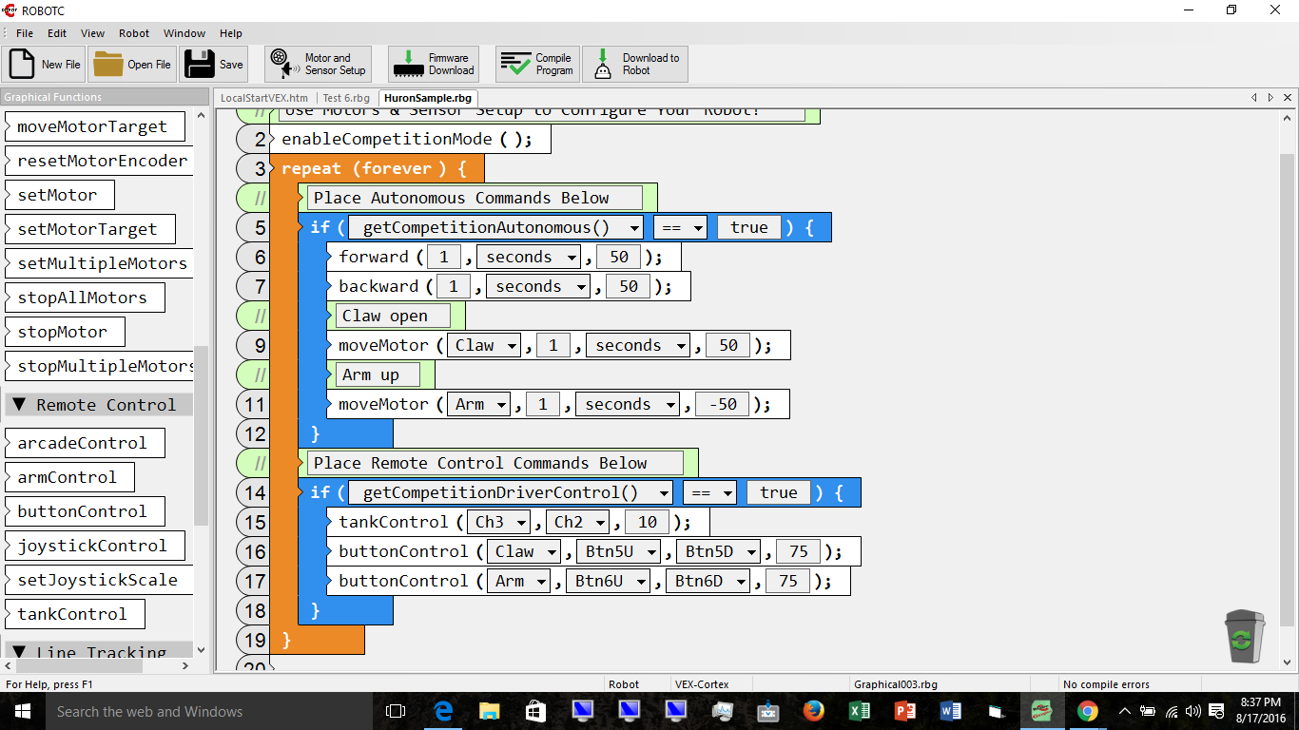

- Open RobotC
- Check Platform Type ( VEX 2.0 for Cortex)
- File - NEW - Competition template (Graphical) will provide all needed structure.
- Use Motor and Sensor setup to configure Robot. Add motors as per your chart.
- From “Simple Behaviors – add any movements you want.
- Add other actions such as claw and arm.
- Under remote control add: Tank control, 2 Button Controls and other movements as wanted.
- Configure button controls.
- File save as – Name the program.
- Download to robot.
Hints:
In Motor and Sensor setup make sure the Drive Motor Side is selected.
Remove any sensor not being used if present.
Use Competition switch to test.
Do not use driver controls in Auton
Do not use auton movements in driver control
No Encoders in motor and sensor setup – change to none.
Avoid rotations and degrees.

