Monday April 27th
Mini-lab
GET OUTSIDE, but use social distancing!!!
Today we want you to get outside and take 2-4 pictures of things in nature. Then label which process (photosynthesis/Cellular Respiration) the organisms in your pictures MAINLY use. Then post on Twitter
@MrGravesLHSBio
@TheBurgScience #TeamDCS

or send it directly to me by Remind or Email
example
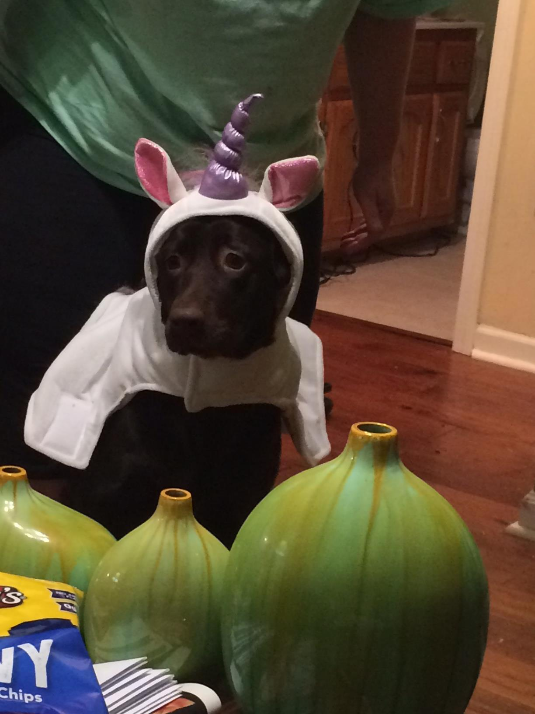
Cell Respiration

