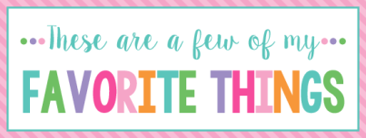

Name:________________________ T Shirt Size:____________________
Birthday:_____________________ Monogram:______________________
Favorite Color:________________ Favorite Flower:_________________
Favorite Scent:________________ Favorite Candy:_________________
Favorite Drink:________________ Favorite Food:__________________
Favorite Snack:________________ Favorite Fruit:__________________
Favorite Restaurant:____________________________________________
Favorite Fast Food:_____________________________________________
Favorite Places to Shop:________________________________________
Favorite Bath & Body Works Scent:______________________________
Favorite Author /Book Series for my own personal reading:________________________________________________________
Favorite Author /Book Series for my classroom library:__________________________________________________________
Wish List for Classroom:_________________________________________
_________________________________________________________________
** Please turn in to Mrs. Still by Friday, August 5.***

