Parent(s), Graded papers go home tomorrow – return ASAP or at the latest Friday. Thank you for your continued support. Please be sure you are checking your child’s backpack and folder daily. Send a note, or email me if needed (karla.thompson@dcsms.org). You can also Stay Connected with Remind. Text @g7fc3f to 81010 Standard text message rates apply. Visit remind.com to learn more. Thanks to those parents already registered! ☺

Classroom Newsletter November 18,2019
Mrs. Thompson – 3rd Grade
Thanksgiving Break Next Week – No School
November 25-29, 2019

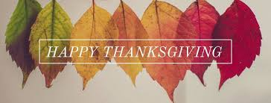
Carleen Moore
Star Student:

Characteristic: confident
Teacher Notes: The math midpoint is Wednesday, November 20. Please be sure your child gets to bed early, has a good breakfast and is completing their homework. The homework they have each week is a spiral review. It gives them daily practice of skills they need to master in order to pass the tests needed to go to 4th grade.

Reading: main idea & details, context clues
Writing: expository non-fiction; punctuation
Math: area; review
Science: rocks & fossils Social Studies: map skills

Classroom
Topics

Good, better, best. Never let it rest. ‘Til your good is better and your better is best. – St. Jerome
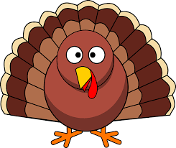 TURKEY FEATHER CONTEST

November 11th-November 22nd
Daily Homework:
- Read, read, read – at least 20 minutes every day; complete daily section of Reading Homework page – A World Without Frogs
- Practice multiplication facts; complete daily section of Math Homework page – Q2:6

School Make-up Pictures – Thursday 11-21-19

Upcoming Tests:
Reading
- Vocabulary Quiz 11/19
- Unit 4 Test: 11/19
Math
- Kicking It Quiz (multiplication facts): 11/19
- Math Midpoint – 11/20

