Mrs. Perrett and Mrs. Holmes’
Weekly Report

October 26-30, 2020

Reading: Our focus this week will be author’s purpose, context clues, and text features.
Vocabulary:
shimmer – shine with a soft, twinkling light
vanish – disappear
expand – grow bigger
stream – steady flow or movement of something
Language:
We will focus on collective nouns.
Science: Earth Science: Sun, Moon, and Stars
Math:
We will continue working with bar and picture graphs.
We will continue working with shapes and attributes (triangles, quadrilaterals, pentagons, hexagons, and cubes).
Assessments: (Friday)
Spelling Test
Math Test on graphs and shapes
Fact Fluency
Reading Comprehension Test 1
Special Notes

- Fact Fluency tests will be every Friday. Please work on addition and subtraction facts daily.
- Homework is due on Fridays.
- P.E. will be on Thursday this week.
- Thank you for all that you do!!

Please do not forget to bring the treats for Friday. We have 23 students. Also, Friday is book character day.
Spelling Words

cash, shelf, shut, pinch, chick, math, fifth, this, stack, smack, upset, until, index, contest, cactus, vest, twin, trot, stump, print

Wish List
Small items for treasure chest

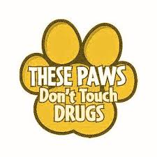
Red Ribbon Week
Say “BOO” to Drugs!
October 26-30
- Monday: Put a cap on drugs! Wear your favorite hat and deck yourself out in red clothing to kick off Red Ribbon Week!
- Tuesday: Sock it to drugs! Crazy Sock Day
- Wednesday: We are hunting for drug-free kids! Wear your hunting clothes to school!
- Thursday: Follow your dreams and steer clear of drugs! Pajama Day
- Friday: Say “BOO” to drugs! Dress as your favorite book character!

